**Java Collection Framework**

| **PROPERTIES** | **PRIMITIVE DATA TYPES** | **OBJECTS** |
| --- | --- | --- |
| Origin | Pre-defined data types | User-defined data types |
| Stored structure | Stored in a stack | Reference variable is stored in stack and the original object is stored in heap |
| When copied | Two different variables are created along with different assignment (only values are same) | Two reference variables are created but both are pointing to same object on heap |
| When changes are made in the copied variable | Change does not reflect in the original ones. | Changes reflect in the original ones. |
| Default value | Primitive datatypes do not have null as default value | Default value for the reference variable is null |
| Example | byte, short, int, long, float, double, char, boolean | array, string class, interface etc. |

The Collection interface (**java.util.Collection**) and Map interface (**java.util. Map**) are the two main “root” interfaces of Java collection classes.

The **Collection in Java** is a framework that provides an architecture to store and manipulate the group of objects.

**Wrapper Classes in Java**

A Wrapper class is a class whose object wraps or contains a primitive data type. When we create an object to a wrapper class, it contains a field and, in this field, we can store a primitive data type. In other words, we can wrap a primitive value into a wrapper class object.

**Need of Wrapper Classes**

1. They convert primitive data types into objects. Objects are needed if we wish to modify the arguments passed into a method (because primitive types are passed by value).
2. The classes in java.util package handles only objects and hence wrapper classes help in this case also.
3. Data structures in the Collection framework, such as [ArrayList](https://www.geeksforgeeks.org/arraylist-in-java/) and [Vector](https://www.geeksforgeeks.org/vector-vs-arraylist-java/), store only objects (reference types) and not primitive types.
4. An object is needed to support synchronization in multithreading.

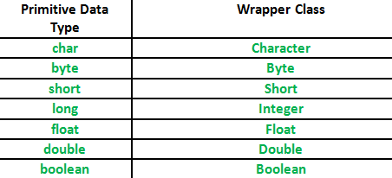

**Autoboxing:** Automatic conversion of primitive types to the object of their corresponding wrapper classes is known as autoboxing. For example – conversion of int to Integer, long to Long, double to Double etc.

arraylist.add(34); -- > // Autoboxing because ArrayList stores only objects

**Unboxing:** It is just the reverse process of autoboxing. Automatically converting an object of a wrapper class to its corresponding primitive type is known as unboxing. For example – conversion of Integer to int

Int a = arraylist.get(34); //unboxing because get method returns an Integer object

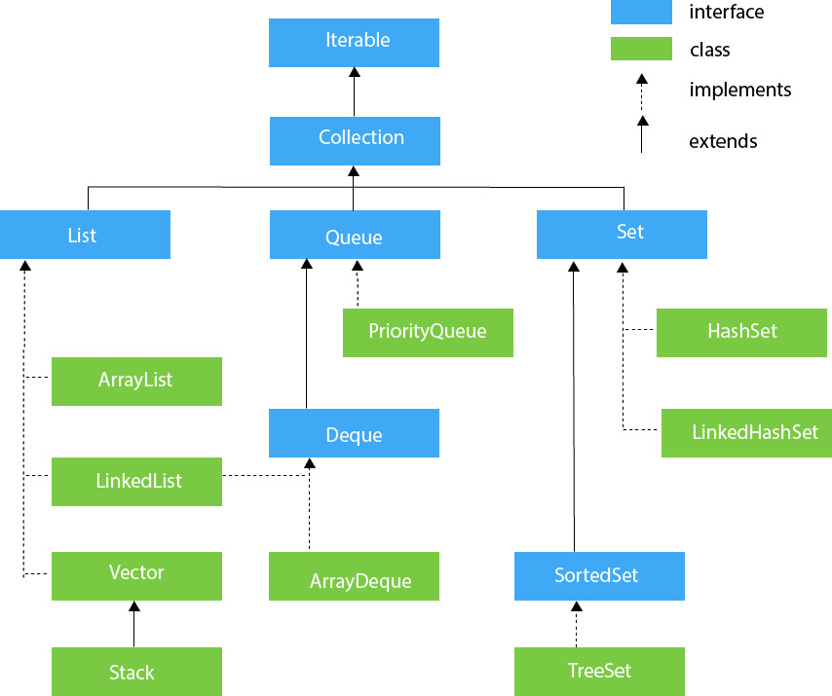

Interfaces with no methods are called marker interfaces in Java.

<http://etutorials.org/Programming/Java+performance+tuning/Chapter+11.+Appropriate+Data+Structures+and+Algorithms/11.6+The+RandomAccess+Interface/>

<http://learnitweb.com/java-7/java-interview-questions/what-is-randomaccess-interface/>

**Methods of the Collection Interface**

This interface contains various methods which can be directly used by all the collections which implement this interface. They are:

Iterator interface

|  |
| --- |
| Iterator interface provides the facility of iterating the elements in a forward direction only. |

Methods of Iterator interface

There are only three methods in the Iterator interface. They are:

public boolean hasNext()

It returns true if the iterator has more elements otherwise it returns false.

public Object next()

It re public void remove()turns the element and moves the cursor pointer to the next element

public void remove()

It removes the last elements returned by the iterator. It is less used.

Iterable Interface contains only one abstract method. i.e.,

Iterator<T> iterator()  It returns the iterator over the elements of type T.

ListIterator Interface is used to traverse the element in a backward and forward direction.

LIST INTERFACE:

List interface is the child interface of Collection interface. It inhibits a list type data structure in which we can store the ordered collection of objects. It can have duplicate values.

List interface is implemented by the classes ArrayList, LinkedList, Vector, and Stack.

To instantiate the List interface, we must use:

List <data-type> list1= **new** ArrayList ();

List <data-type> list2 = **new** LinkedList ();

List <data-type> list3 = **new** Vector ();

List <data-type> list4 = **new** Stack ();

Collections.sort(list2); to sort list

**ArrayList**

* It uses a dynamic array to store the duplicate element of different data types
* It maintains the insertion order and is non-synchronized
* It is like an array, but there is no size limit.
* Java ArrayList allows random access because array works at the index basis.

**Methods**:

add, remove, removeAll, set, get, isEmpty, clear, size, indexOf, contains, addAll

**LinkedList**

* It uses a doubly linked list internally to store the elements
* It can store the duplicate elements
* It maintains the insertion order and is not synchronized.
* In LinkedList, the manipulation is fast because no shifting is required.
* Peek, poll, peekFirst, pop, add, addFirst, clear, clone, size

An ArrayList class can **act as a list** only because it implements List only. LinkedList class can **act as a list and queue** both because it implements List and Deque interfaces.

ArrayList is **better for storing and accessing** data. LinkedList is **better for manipulating**

Vector

* Vector uses a dynamic array to store the data elements. It is similar to ArrayList. However, It is synchronized and contains many methods that are not the part of Collection framework.

Stack

The stack contains all of the methods of Vector class and also provides its methods like boolean push(), boolean peek(), boolean push(object o), which defines its properties.

A Map doesn't allow duplicate keys, but you can have duplicate values. HashMap and LinkedHashMap allow null keys and values, but TreeMap doesn't allow any null key or value.

A Map can't be traversed, so you need to convert it into Set using keySet() or entrySet() method.

|  |  |  |
| --- | --- | --- |
| **HashMap** | | **Hashtable** |
| 1) HashMap is **non synchronized**. It is not-thread safe and can't be shared between many threads without proper synchronization code. | | Hashtable is **synchronized**. It is thread-safe and can be shared with many threads. |
| 2) HashMap **allows one null key and multiple null values**. | | Hashtable **doesn't allow any null key or value**. |
| 3) HashMap is a **new class introduced in JDK 1.2**. | Hashtable is a **legacy class**. | |
| 4) HashMap is **fast**. | | Hashtable is **slow**. |
| 5) We can make the HashMap as synchronized by calling this code Map m = Collections.synchronizedMap(hashMap); | | Hashtable is internally synchronized and can't be unsynchronized. |
| 6) HashMap is **traversed by Iterator**. | | Hashtable is **traversed by Enumerator and Iterator**. |
| 7) Iterator in HashMap is **fail-fast**. | | Enumerator in Hashtable is **not fail-fast**. |
| 8) HashMap inherits **AbstractMap** class. | | Hashtable inherits **Dictionary** class. |

**SET:**

Set is a child of Collection.

Duplication not allowed and insertion order not preserved.

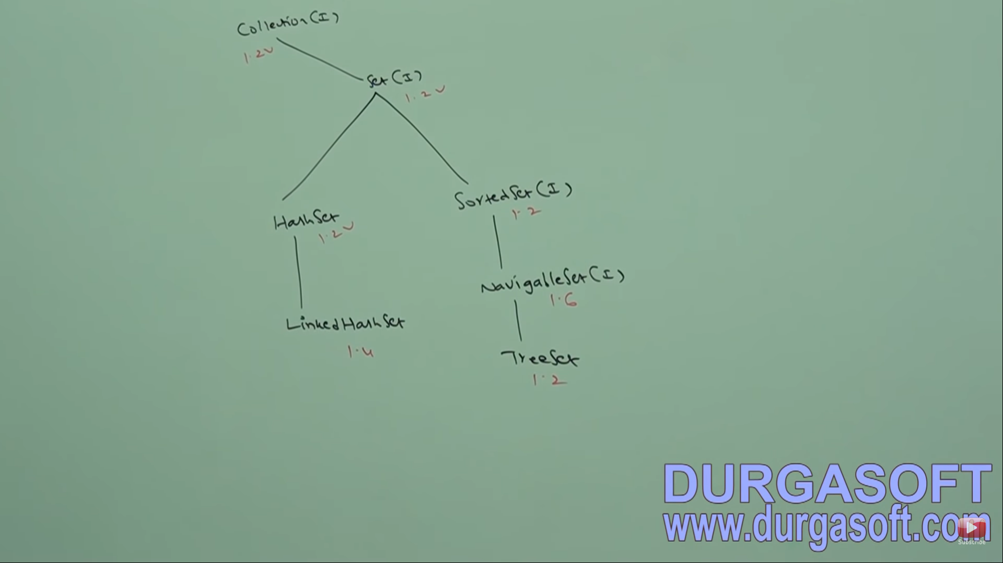

**Insertion based on some sorting i.e. Comparator & Comparable**

**Insertion based on HashCode**

**HASHSET**: It is based on **Hash Table** Data Structure.

Duplication not allowed and insertion order not preserved.

All objects are inserted based on **Hash Code**.

Null can be inserted but inserted only once since duplicates are not allowed.

**Except TREESET and TREEMAP, everywhere HETEROGENOUS objects are allowed.**

Implements SERIALIZABLE, CLONEABLE and **not** RANDOM ACCESS

**Hashing related Data structures are best suitable for Search Operations.**

In HashSet, duplicates are not allowed. If you are trying to insert duplicates then we would not get any compile time or run time error and **add () simply returns false**.

**CONSTRUCTORS:**

**HashSet h = new HashSet();** creates an empty HashSet object with

Default initial capacity **16** and Default Fill Ratio (Load Factor) **0.75** i.e. it will be expanded when it is filled 75%.

**HashSet h = new HashSet(int initialCapacity);** creates empty HashSet object with specified Initial capacity but fill ratio will be 0.75

**HashSet h = new HashSet(int initial Capacity, float fillRatio);** creates empty hashSet object with specified Initial capacity and fill ratio specified.

**HashSet h = new HashSet(Collection c);** creates an equivalent HashSet for the given Collection. This is meant for interconversion between collection objects.

**LINKEDHASHSET**:

It is the child class of HashSet.

It is exactly the same as HashSet (including constructor and methods) except following differences.

Underlying Data Structure for this is **HASHTABLE + LINKEDLIST**.

So, it preserves the insertion order.

Used to develop **Cache Based Applications** where duplicates not allowed and insertion order is preserved.

**SORTEDSET: (I)**

It is a child interface of a set.

All the objects are inserted **according to some sorting** order without duplicates.

Some methods of SortedSet:

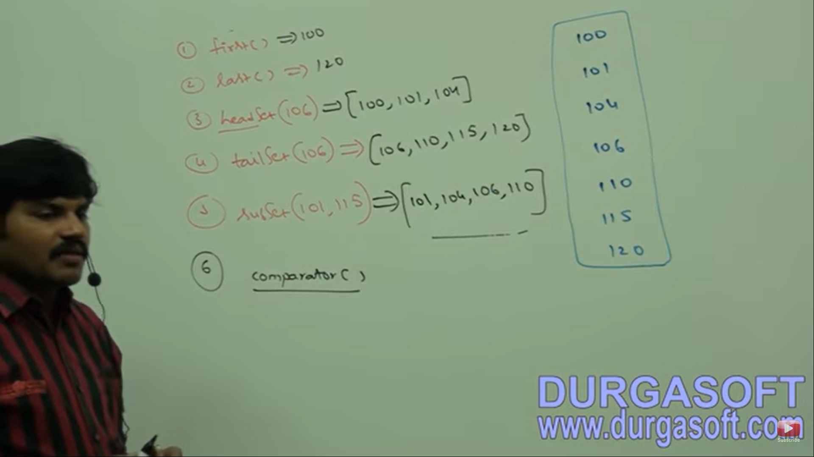

First and last have type **Object** while headSet, tailSet, subSet has type **SortedSet**

**Comparator () returns a comparator object that describes the underlying sorting technique. If we use default sorting order, we will get null.**

**TREESET:**

Underlying Data Structure is **Balanced Tree**

Insertion Order is not preserved.

Heterogenous objects not allowed since comparison is done. **ClassCastException** will be thrown if added

Null Insertion possible but only once.

Implements Serializable, Cloneable but not Random Access

All objects inserted based on some sorting order. It may be **default natural Sorting** order or **customized order.**

**CONSTRUCTORS:**

TreeSet t = new TreeSet(); Creates empty TreeSet objects with default sorting order

TreeSet t = new TreeSet(Comparator c); **Creates empty TreeSet objects with customized sorting order specified by Comparator object**

TreeSet t = new TreeSet(Collection c);

TreeSet t = new TreeSet(SortedSet s);

**Null Acceptance:**

Comparison is done in TreeSet while adding an object. When an object is compared with null, we get Null Pointer Exception.

For an empty TreeSet, if we insert null as the first element, it is acceptable but after that when we add other objects, we will get a Null Pointer Exception.

For non-empty TreeSet, on adding null we get **Null Pointer Exception**.

From Java 1.7 Version, null is not allowed in TreeSet even as a first element.

If we are depending on default sorting, **compulsory the objects should be homogenous and comparable**. An object is said to be comparable if the class implements Comparable interface.

**StringBuffer** adding ---------- > **Class Cast Exception**. Since it does not implement Comparable.

All wrapper classes implement Comparable interface.

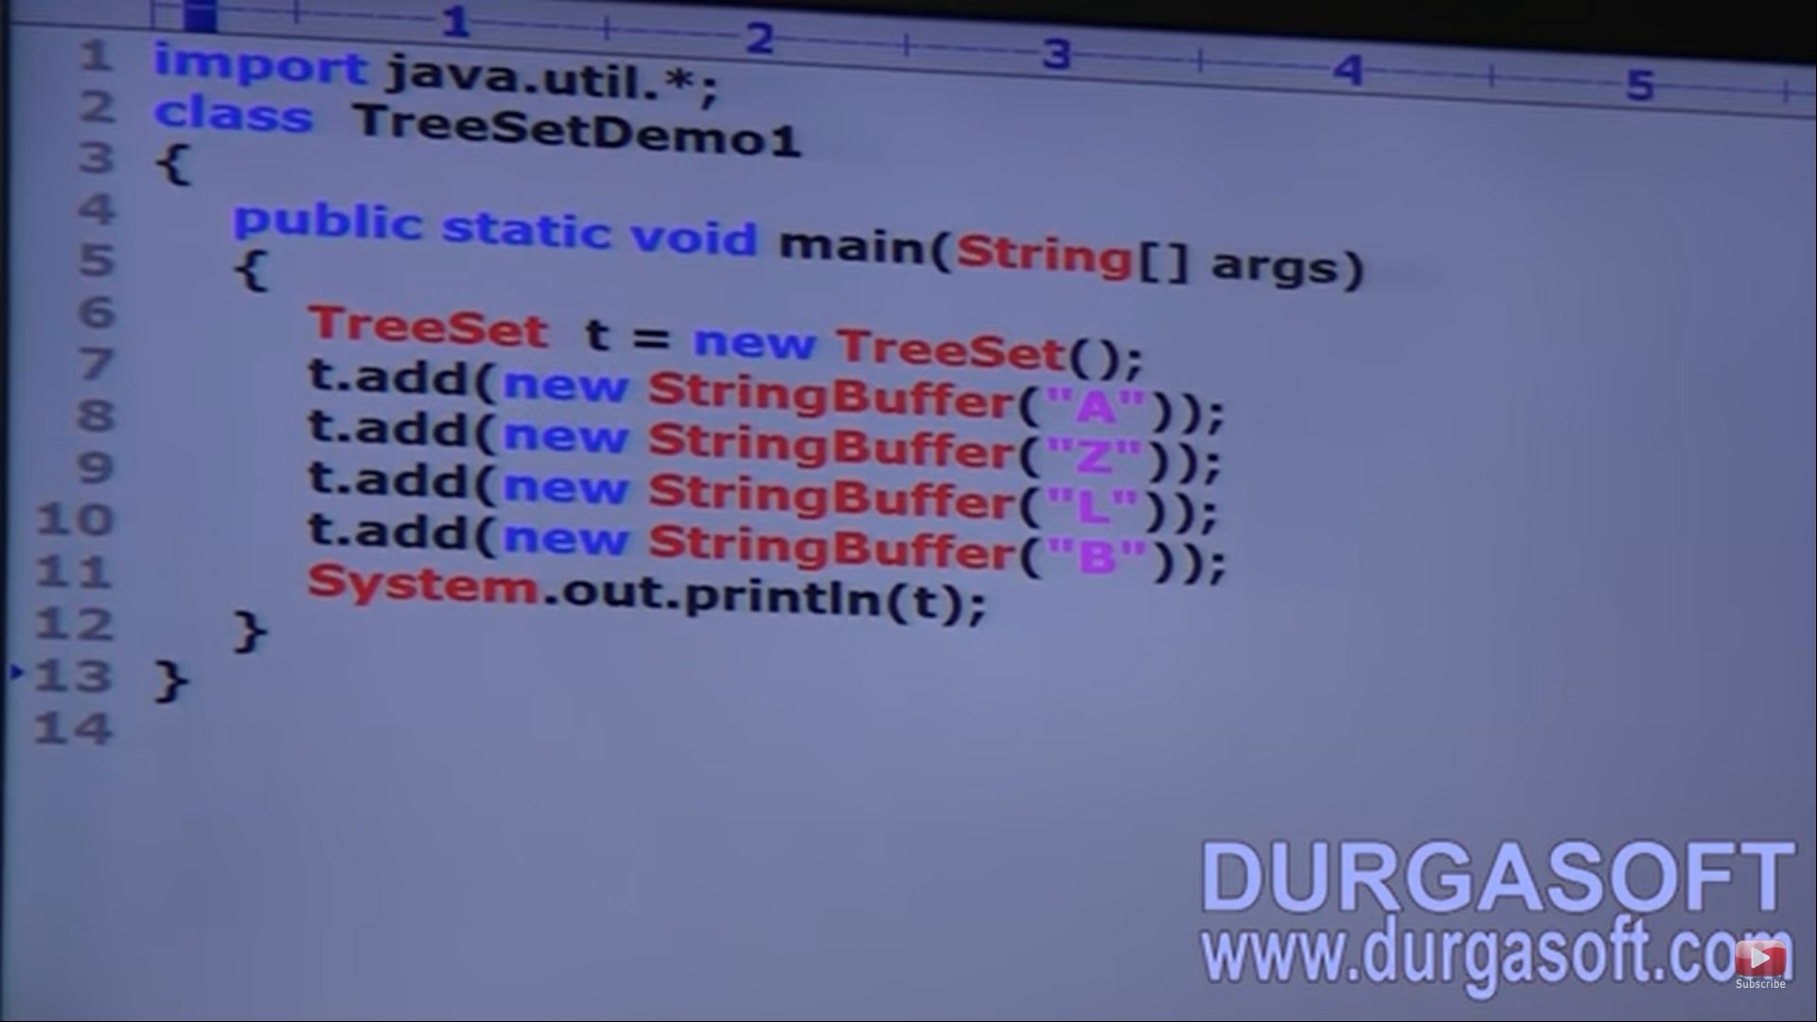ClassCastException thrown

**COMPARABLE INTERFACE**:

It is present in **java.lang** package and it contains only one method **compareTo()**

The return type of this method is **int** since 3 categories are present (positive, negative and equal)

obj1.compareTo(obj2)

**Negative ----------- > obj1 comes before obj2**

**Positive ----------- > obj1 comes after obj2**

**Zero ----------- > obj1 equals obj2**

In default sorting, the compareTo method is called internally. The object which is added is obj1 here and obj2 is one which is already inserted.

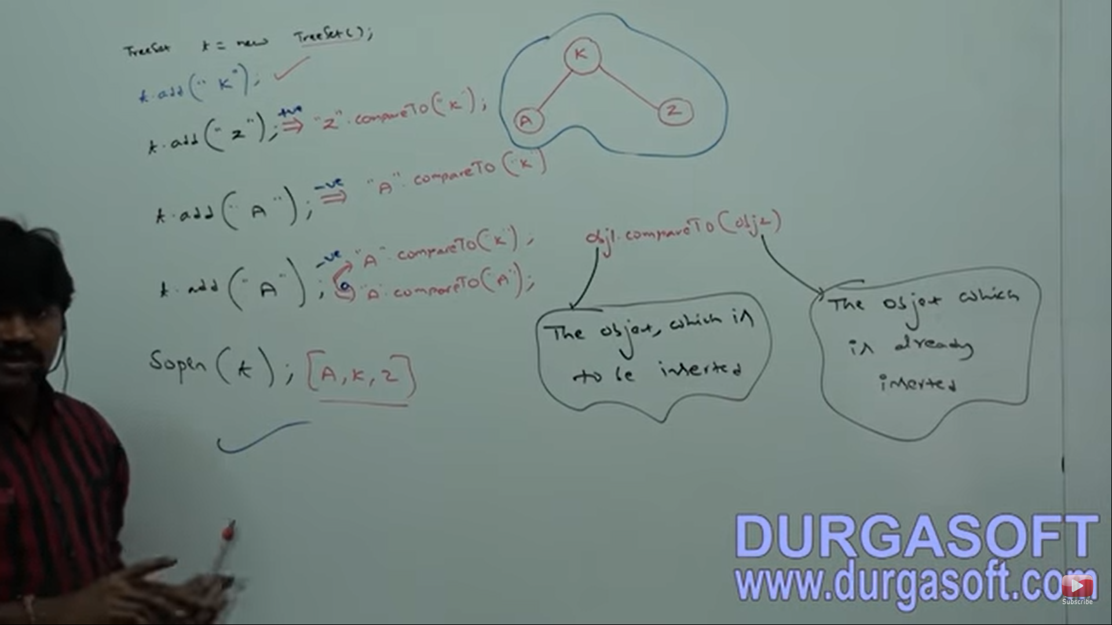

If you are not satisfied with the default sorting order, we can go for customized sorting by using comparator.

**COMPARABLE** used for default sorting order and **COMPARATOR** used for customized sorting order.

**COMPARATOR:**

It is present in java.util package and it contains two methods **compare()** and **equals()**

**public int compare(obj1, obj2)** and **public boolean equals (obj1, obj2)**

Whenever we are implementing a comparator interface, we only have to provide **implementation for the compare method** only and not for equals method because it is already available to our class from Object class through inheritance.

EX: We have to pass the object of the class in the TreeSet.

If negative -- > object2 placed after obj1

**Positive ---- > Object placed before**

**Zero ------- > Duplicate object present**

Here JVM will know only about the compare method and it will call compare method meant for customized sorting. If a comparator object is not passed, Default sorting method will be followed.

Here, new object first compared with 10. Now if on the left / right of 10 other objects present, then a new object will be compared with that object.

**INORDER TRAVERSAL** will be done to form the final array of sorted objects.

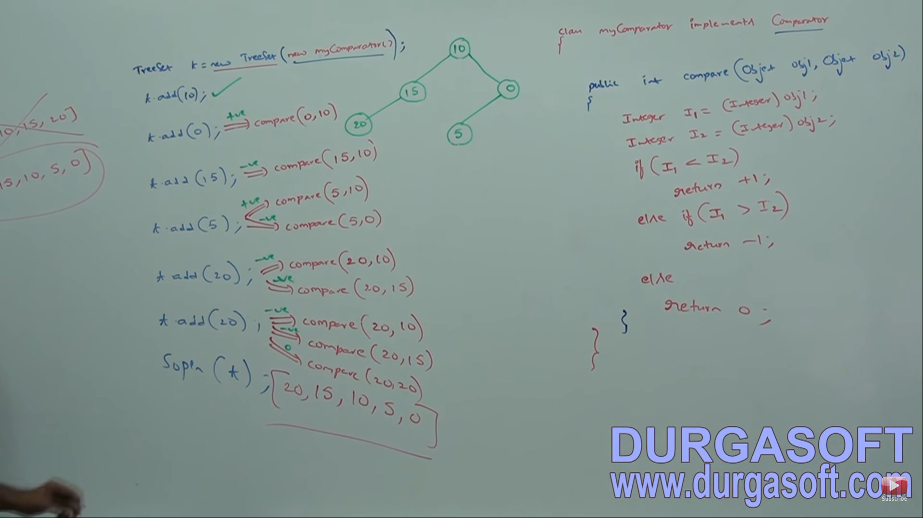

**Different implementations of Compare method:**

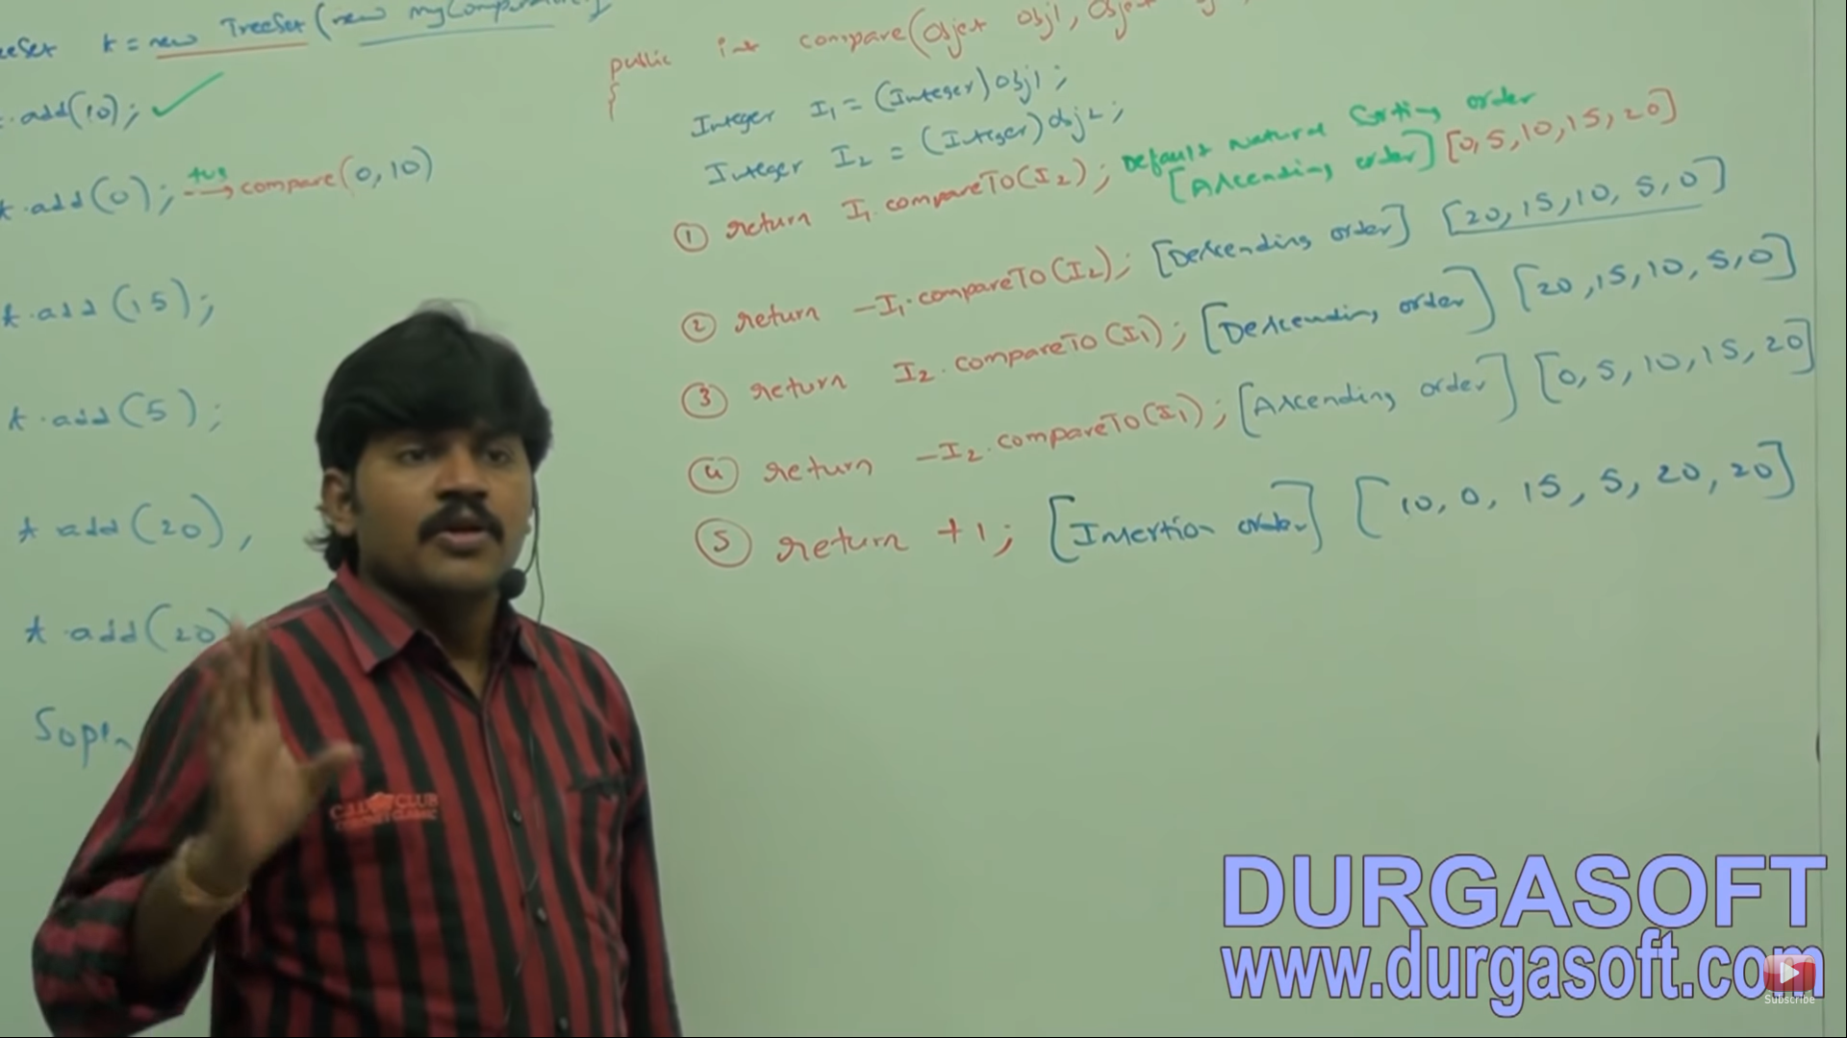

Return +1 will add duplicates since compare method does not tell for duplicates so duplicates will be added.

If returned 0, all other elements will be duplicates and will not be inserted.

If StringBuffer objects needs to be added, use comparator

If we're depending on default sorting order, objects should be homogenous and comparable otherwise we will get a runtime exception saying ClassCastException. If we are defining our own sorting**, then objects need not be comparable and homogenous** i.e. we can add heterogenous non-comparable objects also.

**COMPARABLE VS COMPARATOR:**

For predefined comparable classes, default sorting order already available. We are not satisfied with that order, we can define our own sorting by using the comparator.

For predefined non-comparable classes like StringBuffer, default sorting order not available. We can define our own sorting by using a comparator.

For our own classes like Employee, the person who is writing the class is responsible to define default sorting order by implementing a comparable interface. He can override the compareTo method and define his own sorting for the objects of that class.

The person who is using our class, if he is not satisfied with the default sorting order, then he can define his own sorting by using comparator.

|  |  |
| --- | --- |
| **COMPARABLE** | **COMPARATOR** |
| It is meant for default natural sorting order. | It is meant for customized sorting order. |
| Present in java.lang package | Present in java.util |
| It defines only one method compareTo() | 2 methods - compare() & equals() |
| String and all wrapper classes implement comparable. | The only classes which implement this is  **Collator** and **RuleBaseCollator** |

|  |  |  |  |
| --- | --- | --- | --- |
| **PROPERTY** | **HASHSET** | **LINKEDHASHSET** | **TREESET** |
| **Underlying DS** | Hashtable | LinkedList + Hashtable | Balanced Tree |
| **Duplicate Object** | Not Allowed | Not Allowed | Not Allowed |
| **Insertion Order** | Not preserved | Preserved | Not preserved |
| **Sorting Order** | N.A. | N.A. | Applicable |
| **Heterogeneous Object** | Allowed | Allowed | Not allowed |
| **Null Acceptance** | Allowed | Allowed | Allowed. For empty TreeSet, as first element Null is allowed |

Note: Heterogeneous Object allowed in TreeSet if we use a comparator.

**MAP:**

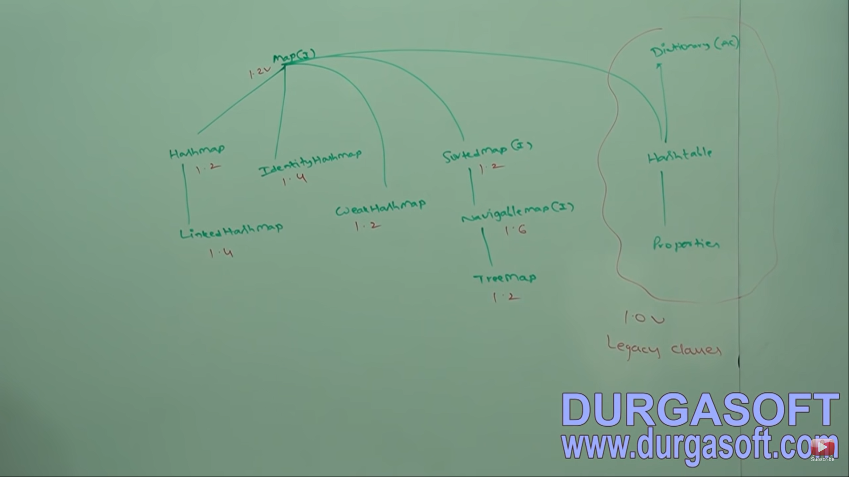

Map is **not** a child interface of Collection. So, **collection methods cannot be used here**. It has its own specific methods.

If we want to represent a group of objects as **key-value pairs**, then we should go for a map.

Both keys and values are objects only.

Duplicate keys are not allowed but values can be duplicate.

Each key-value pair is called an **ENTRY**. Hence map is considered as a collection of entry objects.

**Map interface methods:**

**Object put(Object key, Object value);** to add a key-value pair to the Map

If the key is already present, then the old value will be replaced with a new value and **returns the old value**.

**void pullAll(Map m);** group of key-value pairs will be added

**Object get(key);** returns the value associated with the specified key

**Object remove(key);** removes the entry associated with the specified key

**boolean containsKey();**

**boolean containsValue();**

**boolean isEmpty();**

**int size();**

**void clear();**

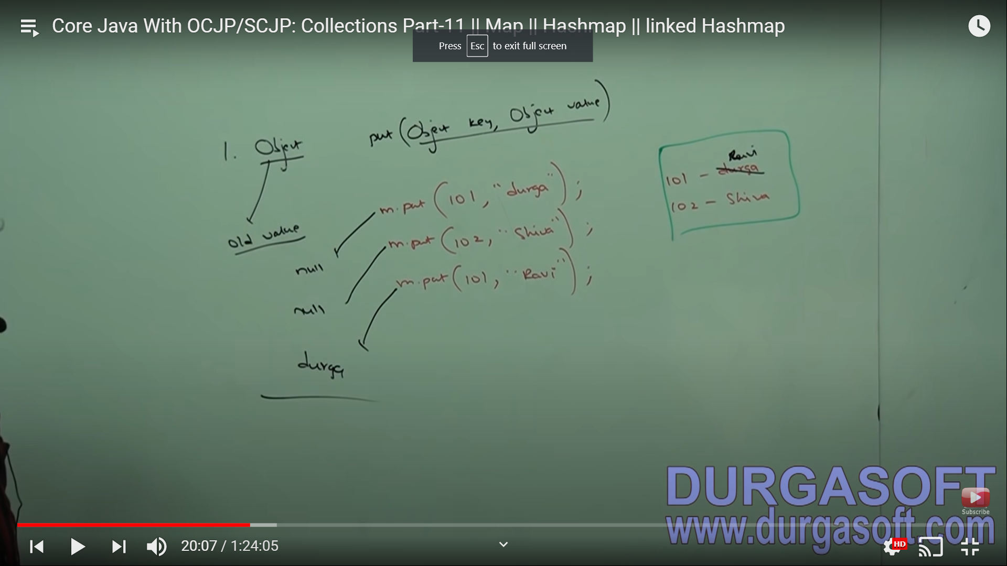

These methods are to be applied on the map object. These 3 methods are called **COLLECTION VIEWS of MAP** since return type is not map & is Collection related terminology.

**Set keySet();** returns all the keys. Return type is Set since duplicates are not present.

**Collection values();**

**Set entrySet();**

**ENTRY INTERFACE:**

Map is considered a group of entry objects. Without an existing Map Object there is no chance of an existing Entry object. Hence, Entry Interface is defined inside Map Interface.

There are 3 methods which we can apply **only** on Entry Objects.

**Object getKey(); Object getValue ();**

**Object setValue();**

**HASHMAP:**

Underlying Data Structure is **Hashtable**.

Insertion order is not preserved and it is based on **Hash code of keys.**

Duplicate keys are not allowed **but values can be duplicated.**

**Heterogeneous objects are allowed** for both key and value.

Null is allowed for key (only once). Null is allowed for values (any number of times)

Implements serializable and cloneable but not RA

Best choice if frequent operation is SEARCH operation.

**CONSTRUCTORS:**

HashMap h = new HashMap();

Creates an empty HashMap object with default initial capacity **16** and default fill ratio **0.75**.

HashMap h = new HashMap(int initialCapacity);

HashMap h = new HashMap(int initialCapacity, float fillRatio);

HashMap h = new HashMap(Map m);

Interconversion between Map objects.

**Output of map object will be in {} while collection object will be in [].**

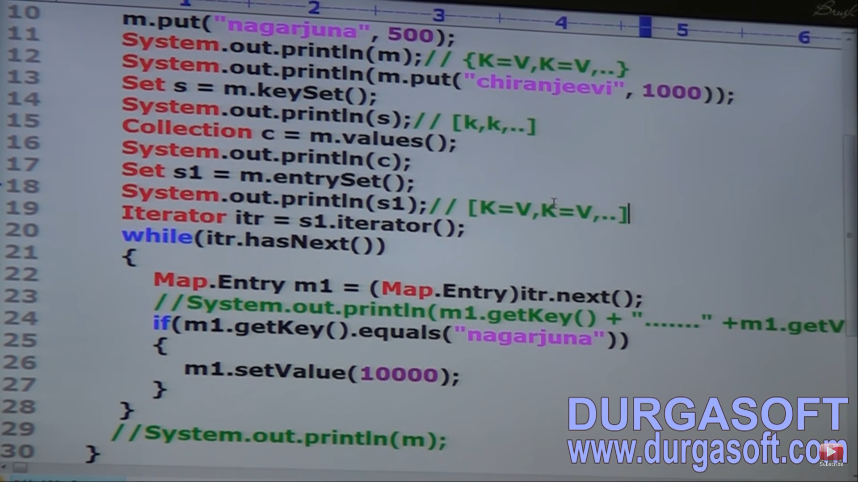

s1 has all the elements in Set form containing Map entries i.e. elements belong to class Map. Now to access key or value, we have to have an Entry object. But the entry interface is inside the map interface. So, we use Map.Entry

|  |  |
| --- | --- |
| **HASHMAP** | **HASHTABLE** |
| Every method is **Not Synchronized** | Every method here is Synchronized |
| **Not thread safe** (multiple threads operated on single object at a time) | Thread safe (Only one thread is allowed to operate on Hash Table at a time) |
| **Performance is high**- because threads are not required to wait on HashMap object | Relatively performance is low |
| **Null is allowed** for key and value | Null not applicable here. Null Pointer Exception thrown |
| Introduced in 1.2v and is not legacy | Introduced in 1.0v and it is legacy |

**How to get a synchronized version of a HashMap object??**

By default, HashMap is non-synchronized. But we can get a synchronized version of HashMap by using the **synchronizedMap method of the Collections class**.

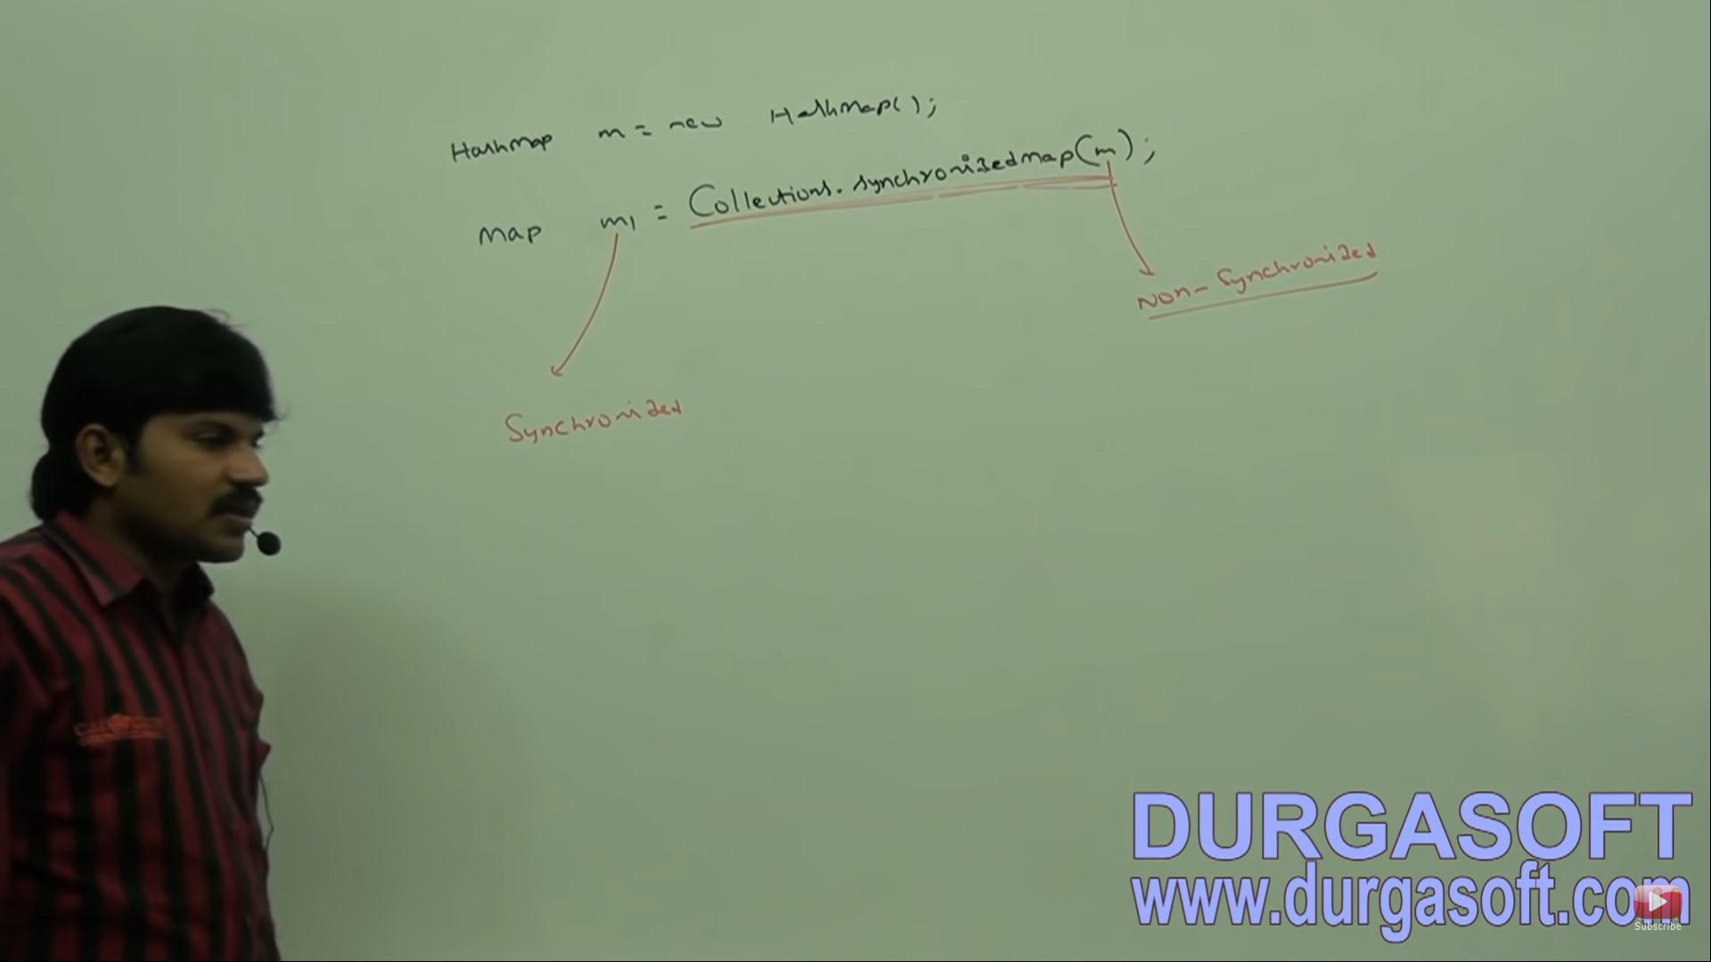

**LINKEDHASHMAP:**

It is the child class of HashMap.

It is exactly same as HashMap (including methods and constructors) except following differences:

|  |  |
| --- | --- |
| **HashMap** | **LinkedHashMap** |
| Underlying Ds is Hashtable | LinkedList + Hashtable |
| Insertion order not preserved and based on Hash Code of keys. | Insertion order is preserved |
| Introduced in 1.2 v | Introduced in 1.4 v |

LinkedHashSet and LinkedHashMap are commonly used for developing cache-based applications.

**Difference between == and equals difference.**

In general, == operator is meant for **reference comparison** where as equals is used for **content comparison**.

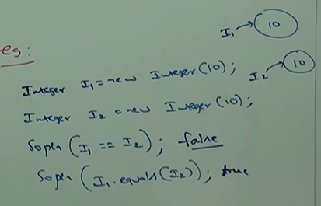

**IDENTITYHASHMAP:**

It is exactly same as HashMap including methods and constructors except following difference.

In case of normal HashMap, **JVM will use equals () to identify duplicate keys** which is meant for content comparison. But in the case of IdentityHashMap, JVM will use ‘==’ operator to identify duplicate keys which is meant for reference comparison (address comparison).

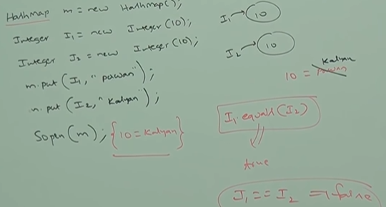

Only one entry will be there if HashMap used but in case of IdentityHashMap, two entries will be present i.e. {10=Pawan, 10=Kalyan}

**WEAKHASHMAP:**

GC: If an object has no reference, it is eligible for GC. But if the object is connected with DB or network, finalize () is called and cleanup activities is performed. Once finalize () is complete, object is garbage collected. **GC calls finalize ().**

If an object is inserted in HashMap and it is set to null, GC will come to destroy it. But HashMap is stronger than GC, so it does not allow GC to destroy the object (Key here). GC then goes to JVM for complain and JVM says GC not to go to HashMap since it is stronger.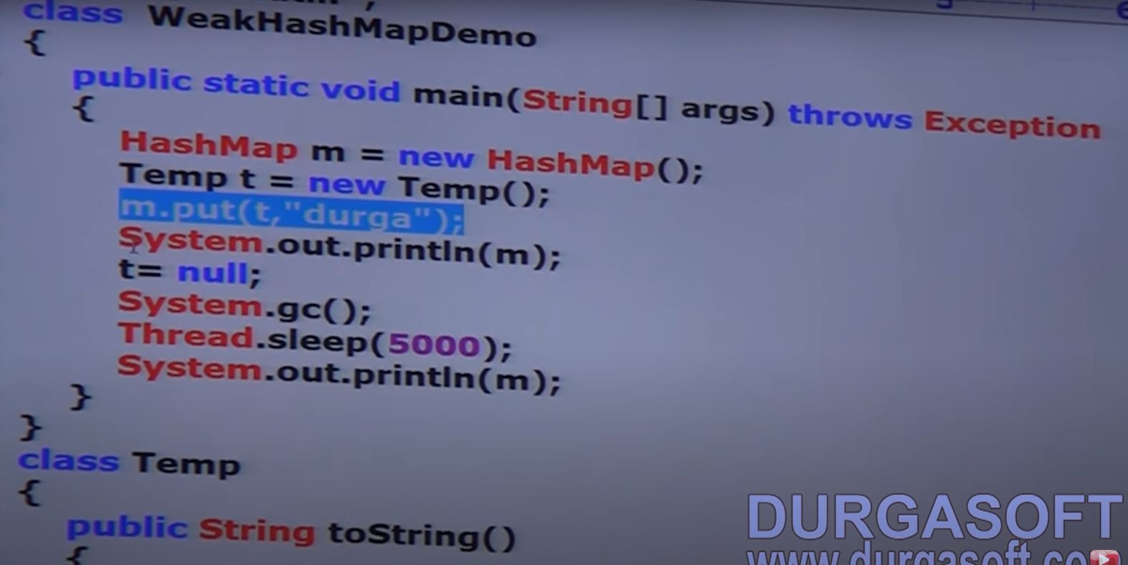

**HashMap and GC ------- > HashMap Dominates**

**WeakHashMap and GC ------- > GC Dominates**

It is exactly same as HashMap except following difference:

In case of HashMap, even though object does not have any reference, it is not eligible for GC, if it is associated with HashMap i.e. HashMap Dominates GC. But in case of Weak, if object does not contain any reference, it is eligible for GC even though object associated with WeakHashMap. i.e. GC dominates WeakHashMap. So the entry is deleted or removed.

**SORTEDMAP:**

It is the child interface of map.

If we want to represent a group of key-value pairs according to some sorting order of keys, then we should go for sorted map.

**Sorting is based on the key and not on value.**

SortedMap defines the following specific method:

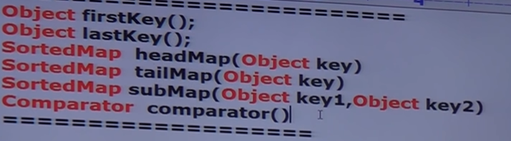

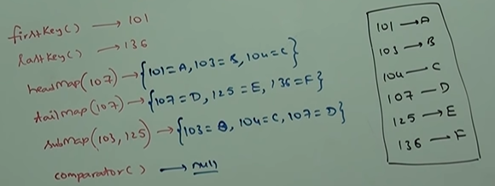

**TREEMAP:**

Underlying Data Structure is **Red-black Tree**.

Insertion order is not preserved and it is based on **some sorting order of keys.**

Duplicate keys are not allowed but values can be duplicated.

**Heterogeneous Objects:** If we are depending on default natural sorting order, then keys should be homogenous and comparable otherwise we will get Runtime Exception -ClassCastException. If we are defining our own sorting through comparator, then keys need not be homogenous and comparable. We can take heterogenous non-comparable objects also. There are no restrictions for values for any sorting order. We can take heterogenous non-comparable objects also.

Null Acceptance:

1. For non-empty TreeMap, if we are trying to insert an entry with null key, then we will get Run time exception – **NPE**.
2. For empty TreeMap as the first entry with null key is allowed. But after inserting that entry, if we are trying to insert any other entry, then we will get runtime exception – NPE.

**Note:** The above Null acceptance Rule applicable till 1.6v only. From 1.7v, **Null is not allowed for key**.

But for values, we can use null any number of times. There is no restriction whether it is 1.6 or 1.7v

**CONSTRUCTORS:**

TreeMap t = new TreeMap (); -- > For Default Sorting Order

TreeMap t = new TreeMap (Comparator c); -- > For customized Sorting Order

TreeMap t = new TreeMap (Map m);

TreeMap t = new TreeMap (SortedMap s);

**HASHTABLE:**

Underlying Data Structure for Hashtable is **Hashtable** only.

**Insertion order** is not preserved and it is based on **Hash Code of keys**.

Duplicate keys are not allowed and values can be duplicated.

**Heterogenous objects are allowed for both keys and values**

**Null is not allowed** for both keys and values. Otherwise we will get Run Time Exception saying -NPE.

It implements Serializable and Cloneable Interfaces but not Random access.

Every method present in Hashtable is synchronized and Hashtable object is thread safe.

Hashtable is the best choice if the frequent operation is Search operation.

**CONSTRUCTORS:**

Hashtable h = new Hashtable ();

Creates an empty Hashtable object with default size = **11** and fill ratio – **0.75**

Hashtable h = new Hashtable (int initalCapacity);

Hashtable h = new Hashtable (int initalCapacity, float fillRatio);

Hashtable h = new Hashtable (Map m);

How hash code plays role while adding objects in the hashing related DS: (basic idea)

Here, The object while we will pass becomes the hash code itself.Return type of toString is string but “I” is object. So, convert it into String.

Default initial capacity is 11. So, 11 buckets will be there.

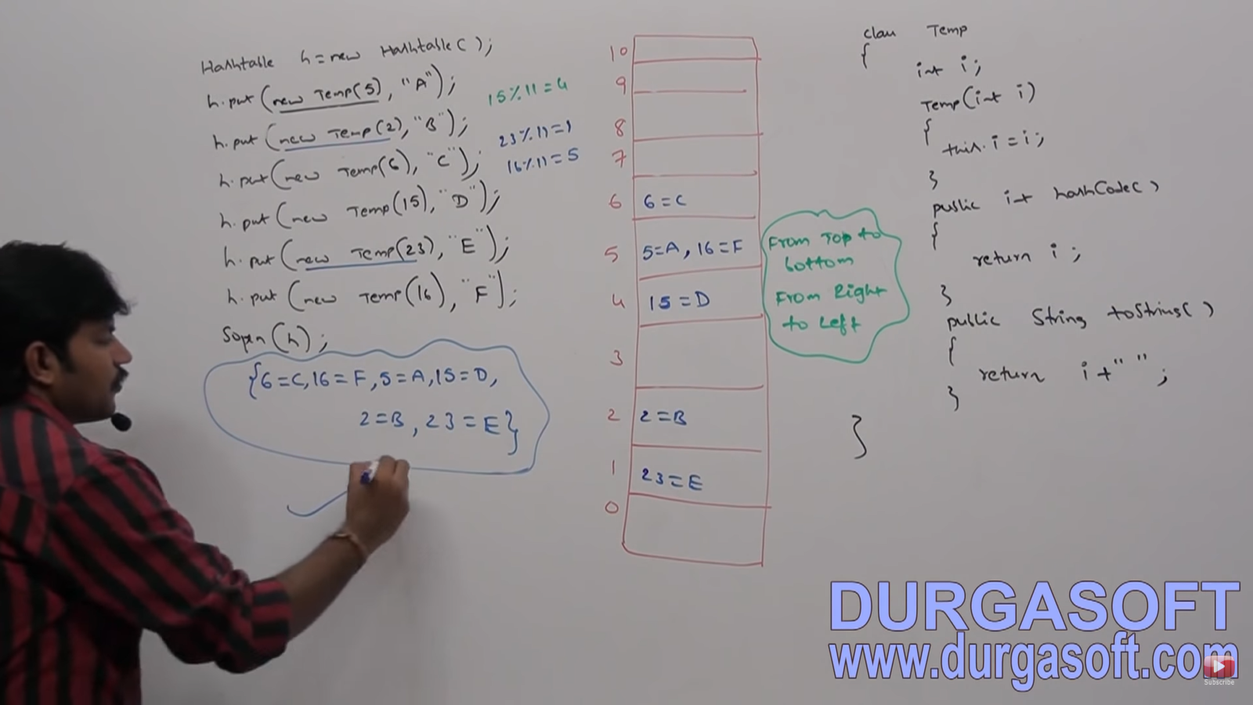

In these DS, data will be saved internally by default. When a new Hashtable would be created, within a bucket how many entries are allowed need not to be worried by the programmer and are abstract.

If you change the initial capacity or hash code the output will change.

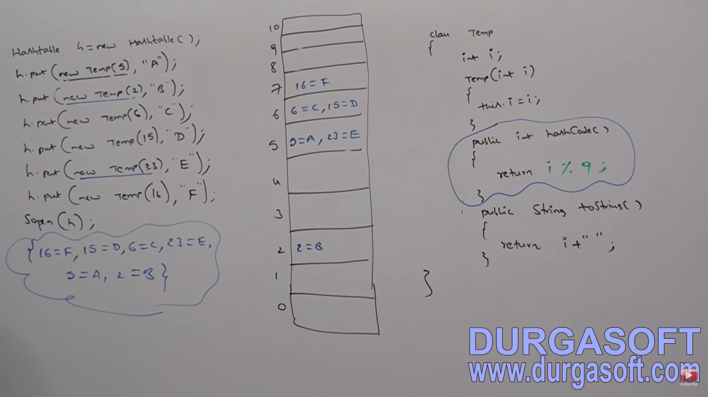

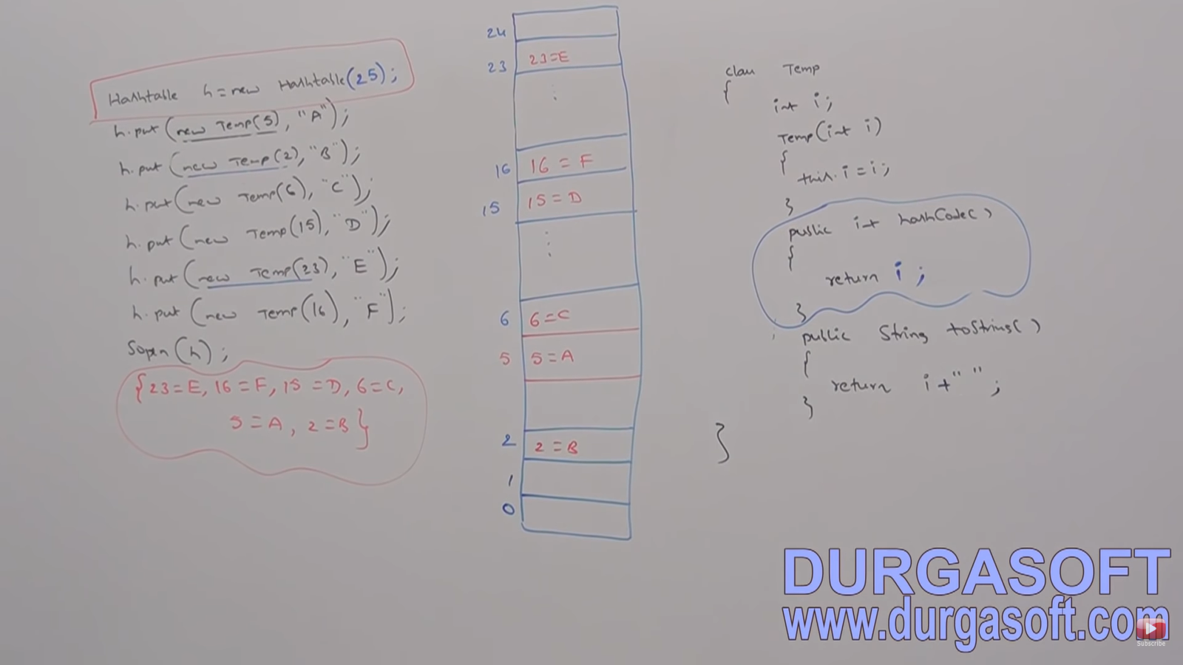

If we configure initial capacity as 25, i.e. Hashtable h = new Hashtable (25);

**PROPERTIES:**

In our program, if anything which changes frequently like username, password, Email, Mobile no etc are not recommended to hardcode in java program because, if there is any change to reflect that change, recompilation, rebuild, redeploy application is required. Even sometimes server restart also required which creates a big business impact to the client.

We can overcome this problem by using properties file. Such type of variable things we have to configure in the properties file. From that property file, we have to read into java program and we can use those properties. The main advantage of this approach is if there is a change in the properties file, to reflect that change **just redeployment is enough** which would not create any business impact to the Client.

We can use java properties object to hold the properties which are coming from properties file.

In Normal map like HashMap, Hashtable, key-value can be any type. But in case of properties, key and value **should be string type**.

Constructors: Properties p = new Properties ();

**Methods:**

**String getProperty (int pName);**

**String setProperty (String pName, String pValue);** if the key already there, old value returned.

**Enumeration propertNames ();**

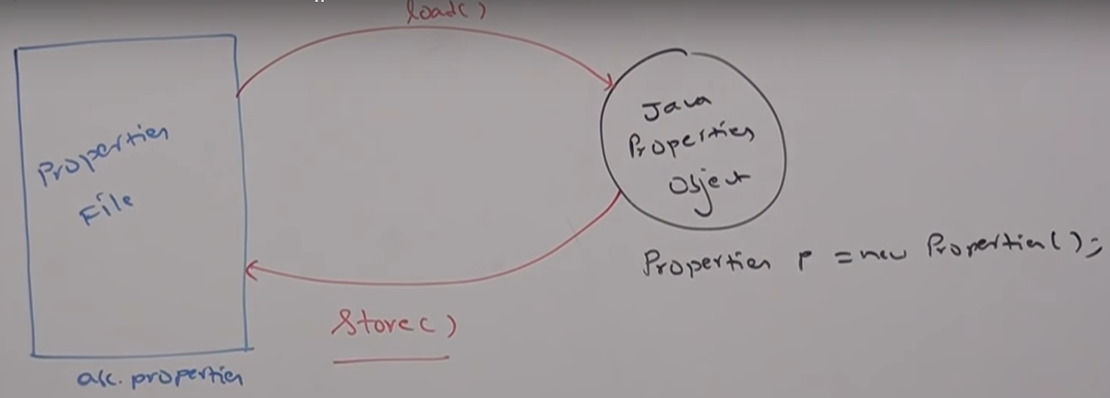

**void load (InputStream is):** To load properties from properties file to java property object.

**void store (OutputStream os, String comment):** To store properties from java properties object to property file

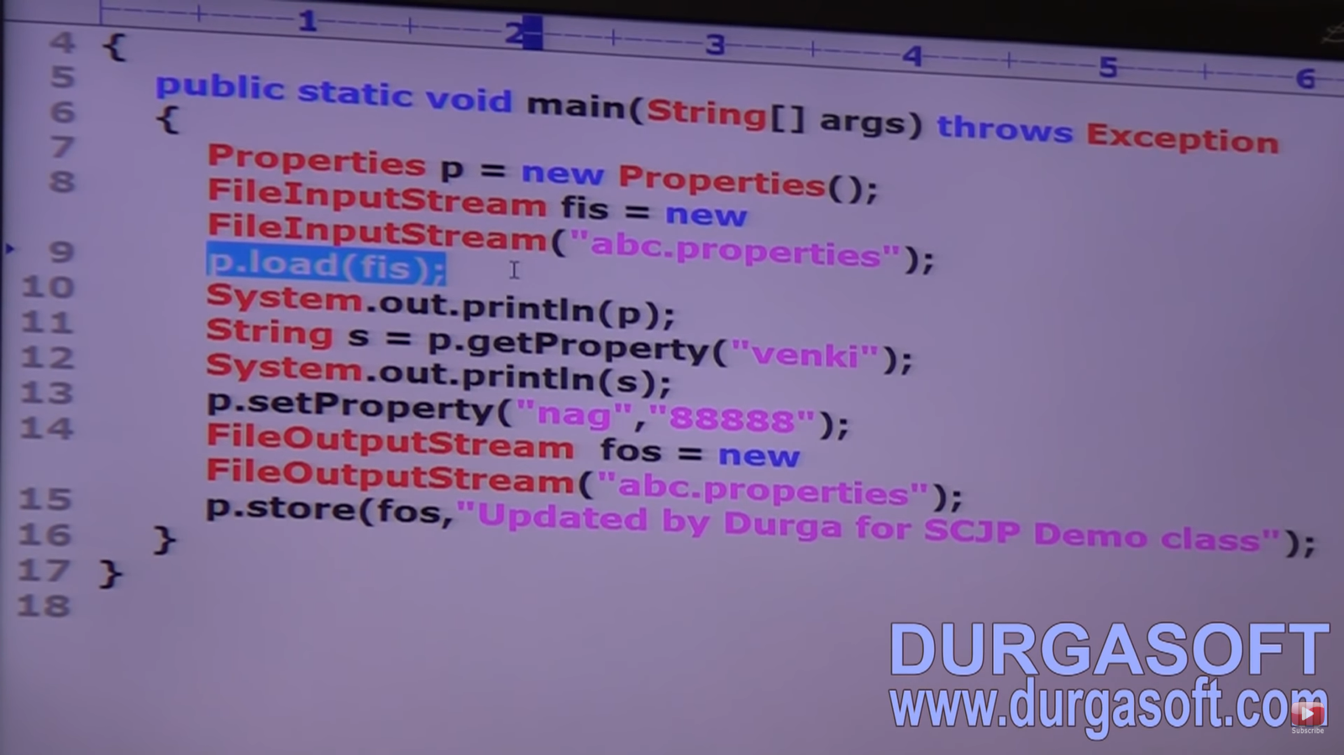

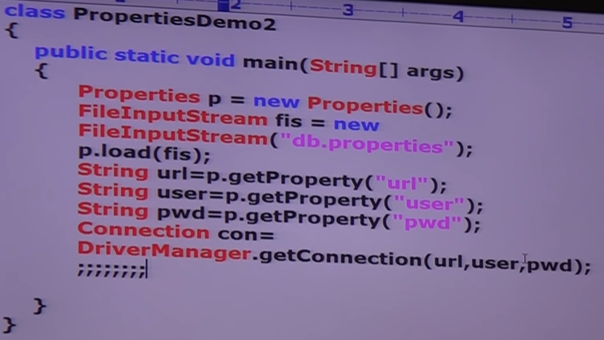

**ENUMS: Came in 1.5v**

Short form for Enumeration.

A **group of named constants** is called Enum. If we want to represent a group of named constants, we should go for enums.

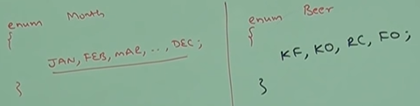

Semicolon is **optional**.

Ex: Month is my own data type with 12 values. Bytes is an inbuilt Data type with values between -127 to 127.

It is used to define **our own data types**. The main objective of emun is to define our own data types (Enumerated Data Types).

Enum introduced in 1.5v. When compared with old languages Enum, Java Enum is more powerful.

**INTERNAL IMPLEMENTATION OF ENUM**:

1. Every ENUM is internally implemented by using Class concept.
2. Every ENUM constant is always **public static final**.
3. Every ENUM constant represents an object of type ENUM.

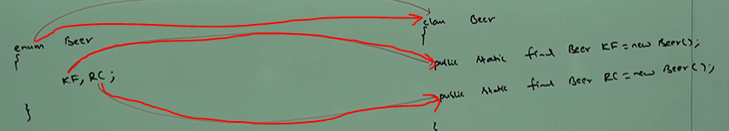

**ENUM DECLARATION AND USAGE**: Every ENUM constant is always public static final and hence we can access ENUM constant using enum name.

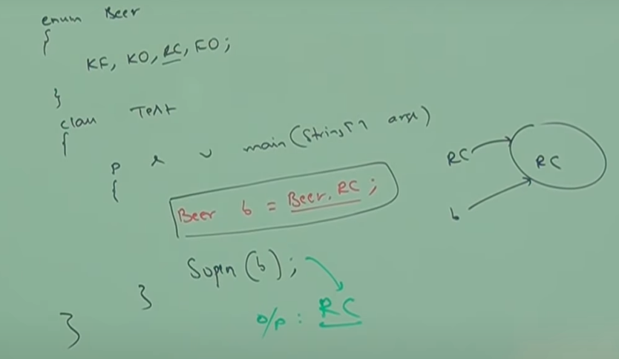

Inside ENUM, **toString** method (this method is always called while printing a reference) is internally implemented to return name of the constant.

We can declare ENUM either within a class or outside but not inside a method. If we declare it inside method, we will get compiler type error saying–**enum types should not be local.**

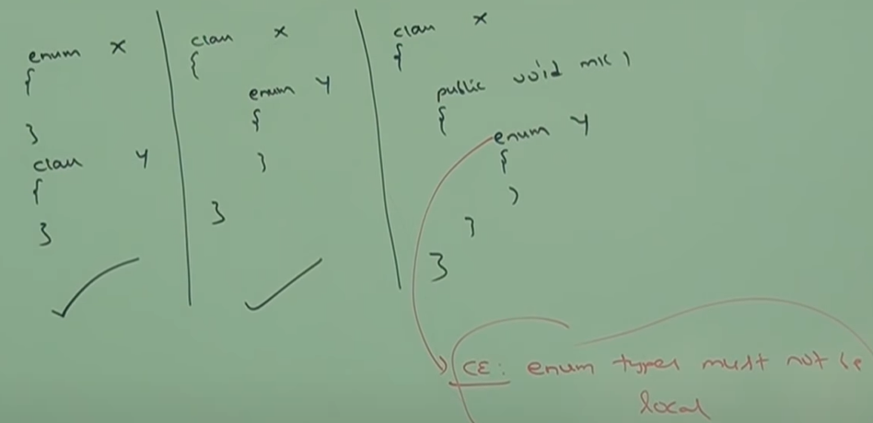

If we declare Enum outside the class, the access modifiers will be **public, strictFp, default**. This is similar to the outer class modifier. Final is not used because an **Enum is always implicitly final** and hence abstract cannot be used.

If declared inside private, protected, static also allowed.

**ENUM vs switch ():**

Until 1.4v the allowed argument types for switch statements are- byte, short, char, int

But from 1.5v onwards, corresponding wrapper classes and enum types are allowed

From 1.7v onwards, String type also allowed.

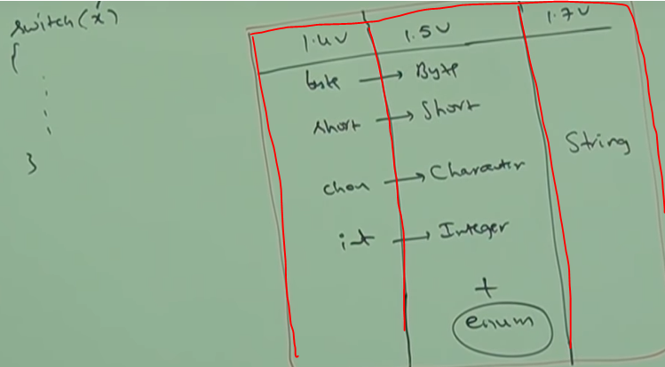

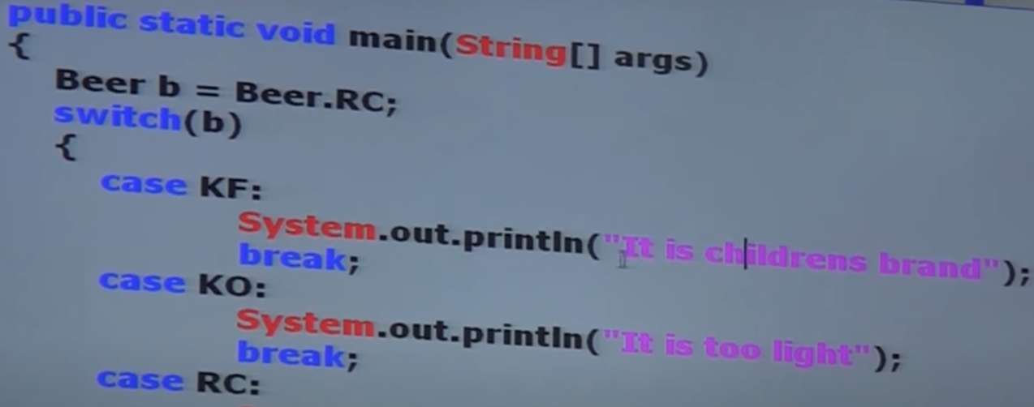

If we pass ENUM type as argument to switch statement, then every **case label should be valid ENUM constant** otherwise we will get compile time error.

**ENUM vs INHERITANCE:**

Every ENUM is always a direct child class of **java.lang.ENUM** and hence our enum cannot extend any other enum (Because Java do not provide support for multiple inheritance)

Every ENUM is always final implicitly and hence for our enum we cannot create child enum.

Because of above reasons we can conclude that inheritance concept not applicable for enum explicitly and **we cannot use extends keyword for ENUM**.

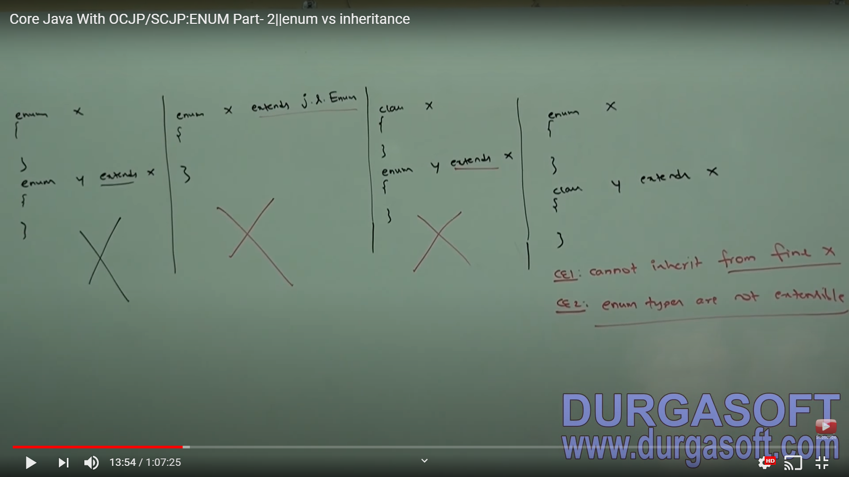

An ENUM can **implement any number** of interfaces.

Every enum in java is a direct child class of java.lang.enum and hence this class acts a base class for all java enums. It is an **abstract class** and is a direct child class of object. It implements serializable and comparable interfaces.

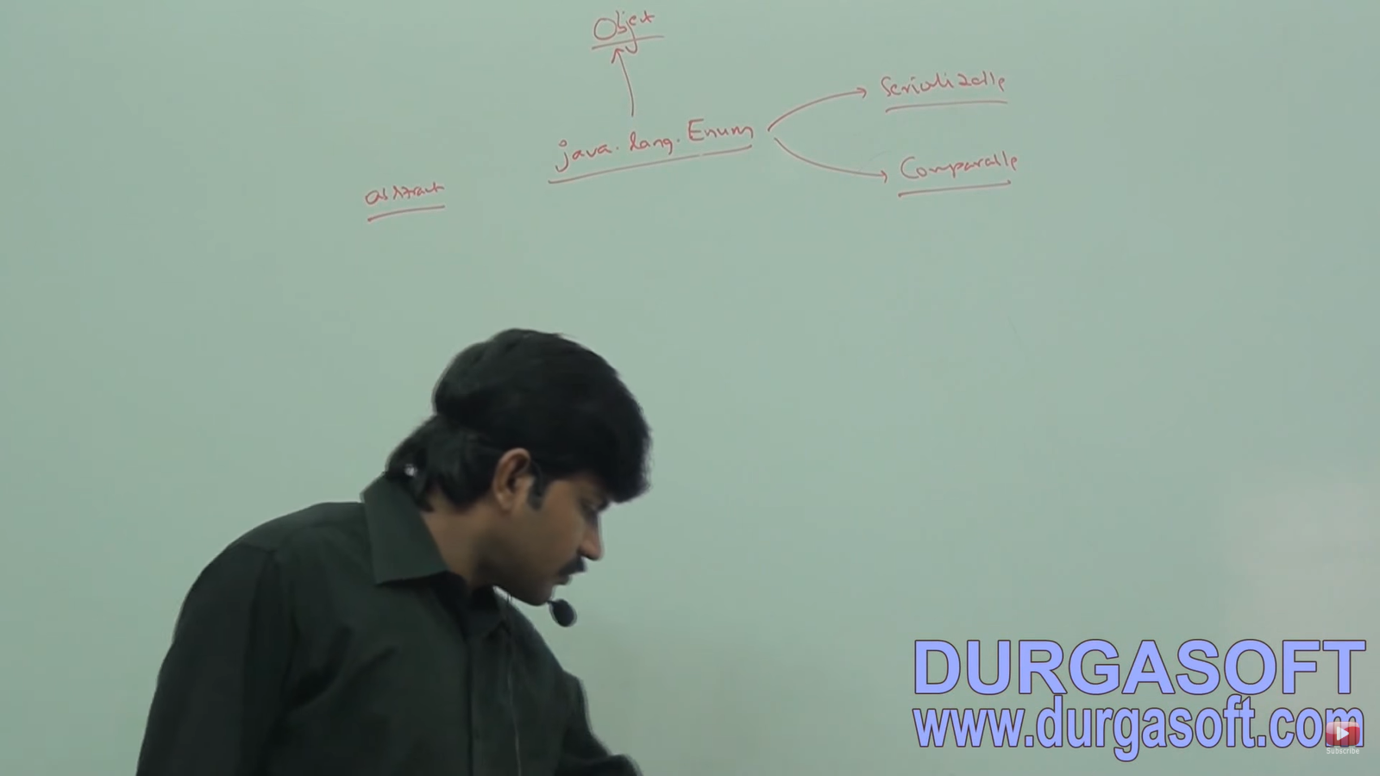

VALUES method: **Beer[] value = beer.values();**

Every enum implicitly contains values method to list out all values present inside enum.

**Note:** Values method is not present in java.lang.Enum and object classes. Enum keyword implicitly provides this method.

**ORDINAL METHOD:**

As index are important in array, **order of constants is also important in enum**. We can represent these using ordinal value. We can find ordinal value of constant using ordinal ().

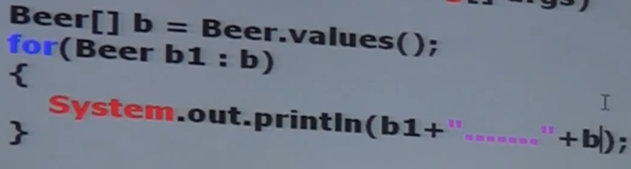

Ordinal value is 0 based like array index.

**SPECIALITY OF JAVA ENUM**:

In old languages enum, we can take only constants. But in java enum, in addition to constants, we can take **methods, constructors, normal variables**. Hence Java enum is more **powerful** than old language enum.

Even in java enum, we can declare main method and we can run enum class directly from command prompt. Here file name should be **Fish.java**

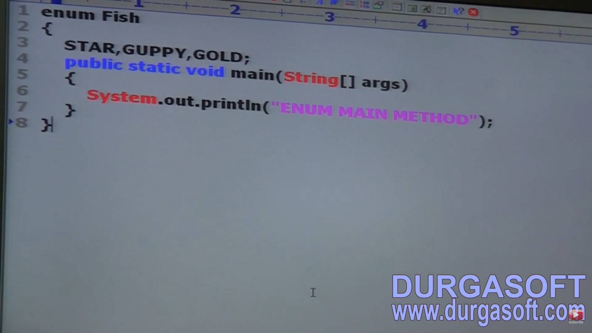

In addition to constants, if we are taking any extra member like method, then list of constants should **always** **be in the first line** and should **ends with semi-colon**.

Inside enum, if we are taking any extra line like methods, first line should contain list of constants or **at least semi-colon**.

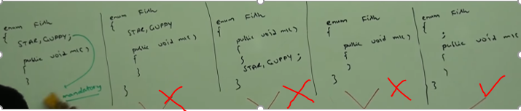

An empty enum is a valid java syntax. Enum fish {}. No semi-colon required here. It is optional.

In a class, static constants can be declared anywhere but in enum we have to compulsorily declare it first.

**ENUM vs CONSTRUCTORS:**

An enum can contain constructor.

Enum constructor will be executed **separately for every enum constant** at the time of enum **class loading automatically**.

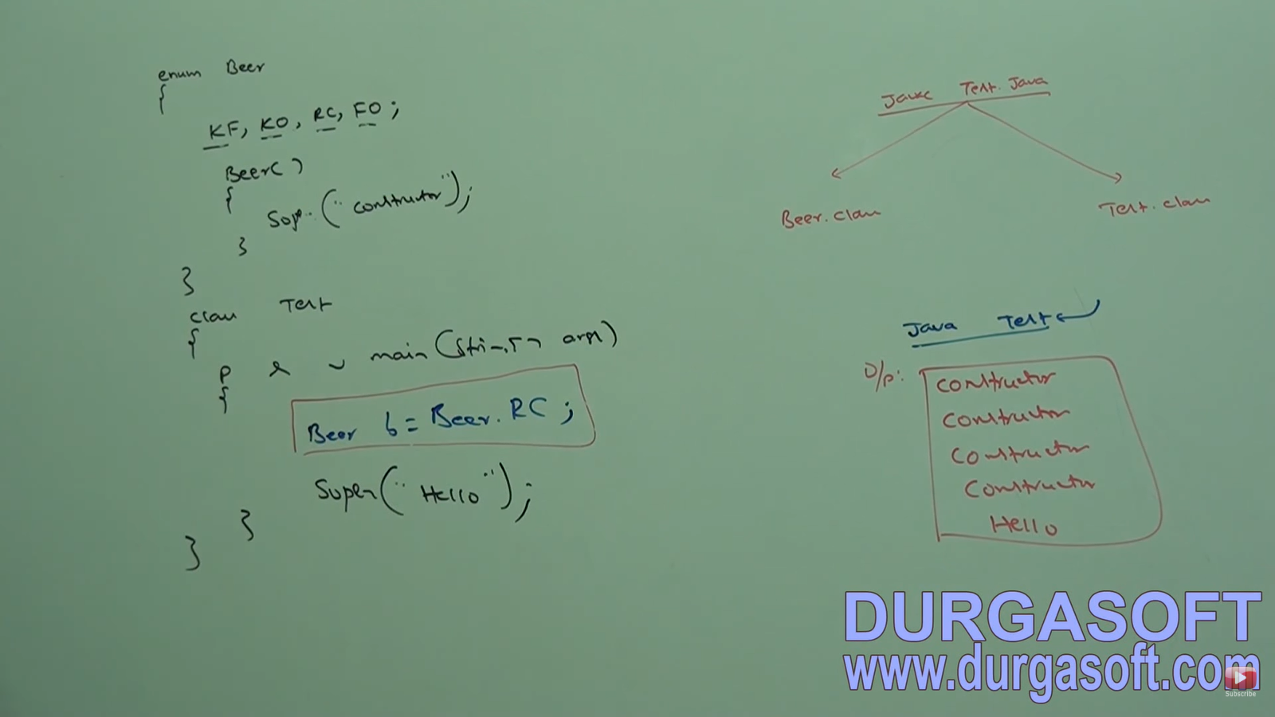

If we comment line in red box, then output is Hello.

We cannot **create enum object directly** hence cannot invoke enum constructor directly.

Beer b = new Beer (); 🡨-------------- **Wrong=> CE: Enum type cannot be instantiated**

In this class we have 4 objects. Every enum constant is an object. And we have created 4 objects. And for each object constructor will be invoked. So, constructor will be invoked 4 times. And every enum constant is static. Static variables will be created at time of class loading. So, enum constructor will be executed separately for every object at time of enum class loading.

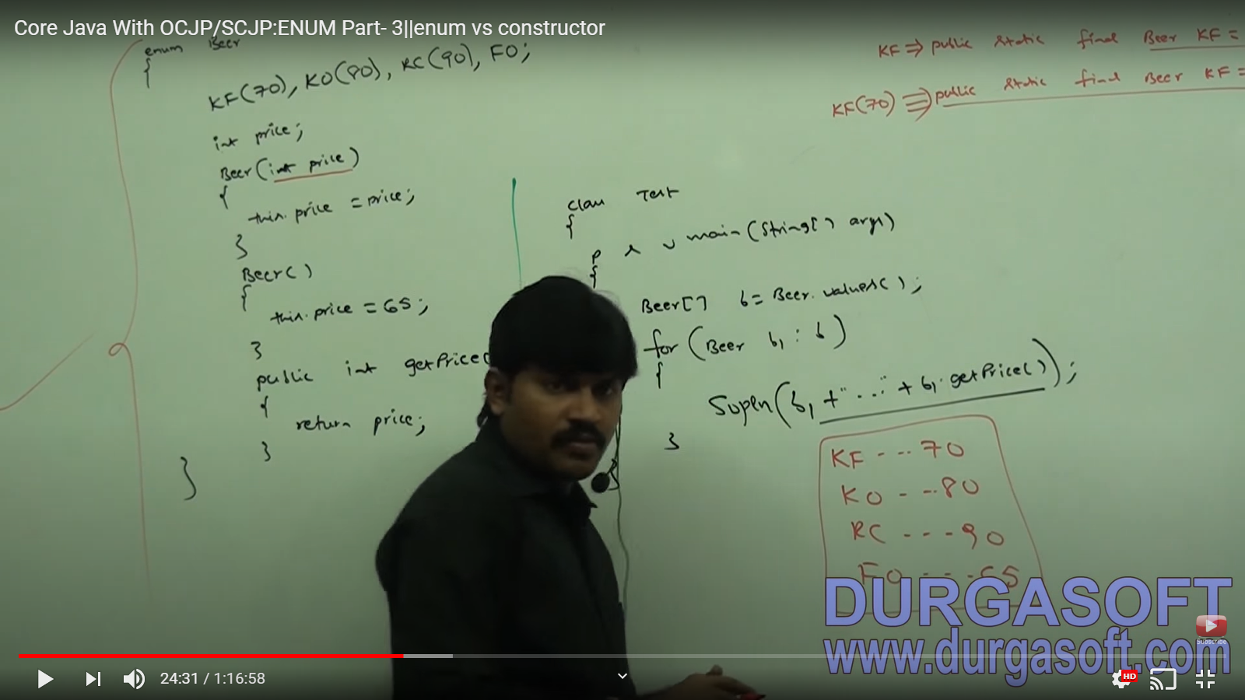

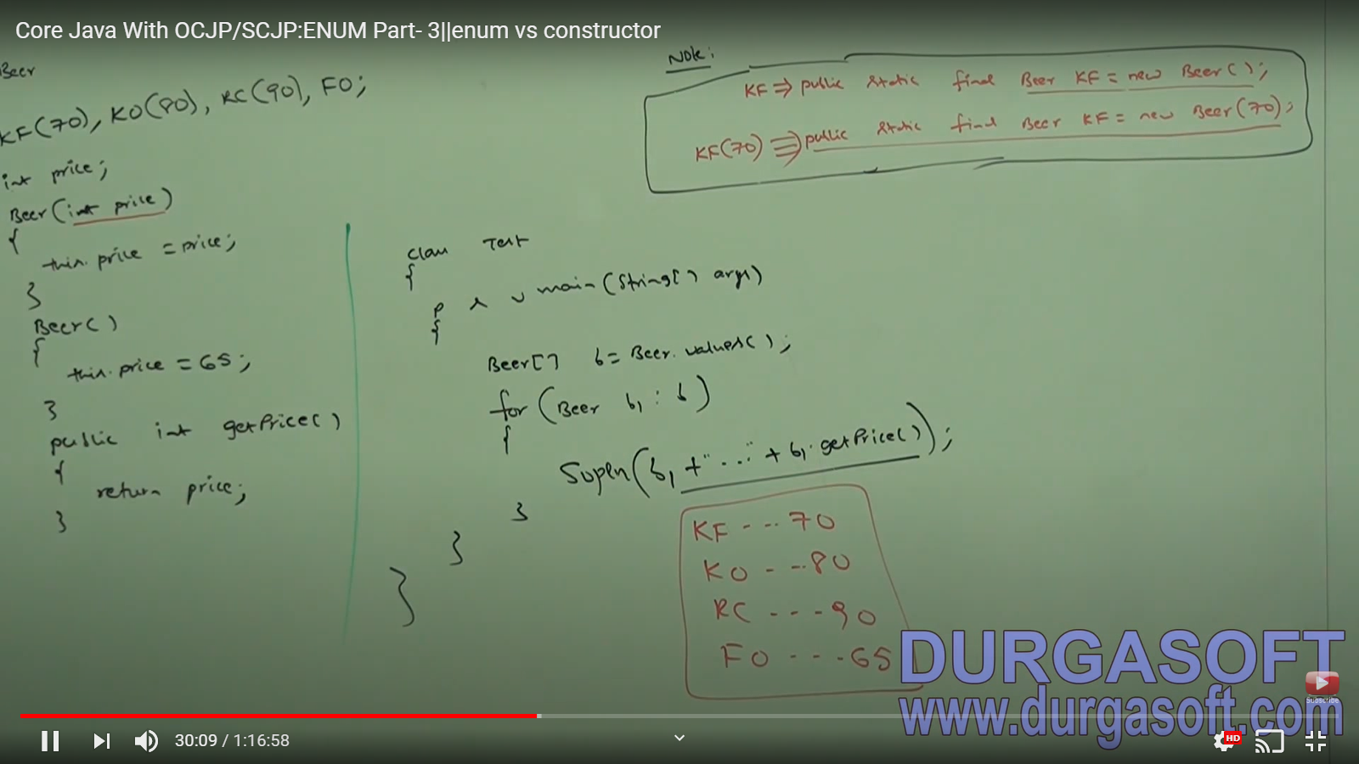

Inside enum, we can declare methods but **only concrete method**. We cannot declare abstract methods because if we declare abstract methods, we have to set enum to be abstract. But enum is implicitly final and hence we cannot declare enum as abstract. **Also, since it is final, we cannot have child.**

Every enum constant is an object. So, every method which we apply on normal java object, we can apply them on enum constants also.

**Third is invalid since we cannot compare 2 object. We can compare their values.**

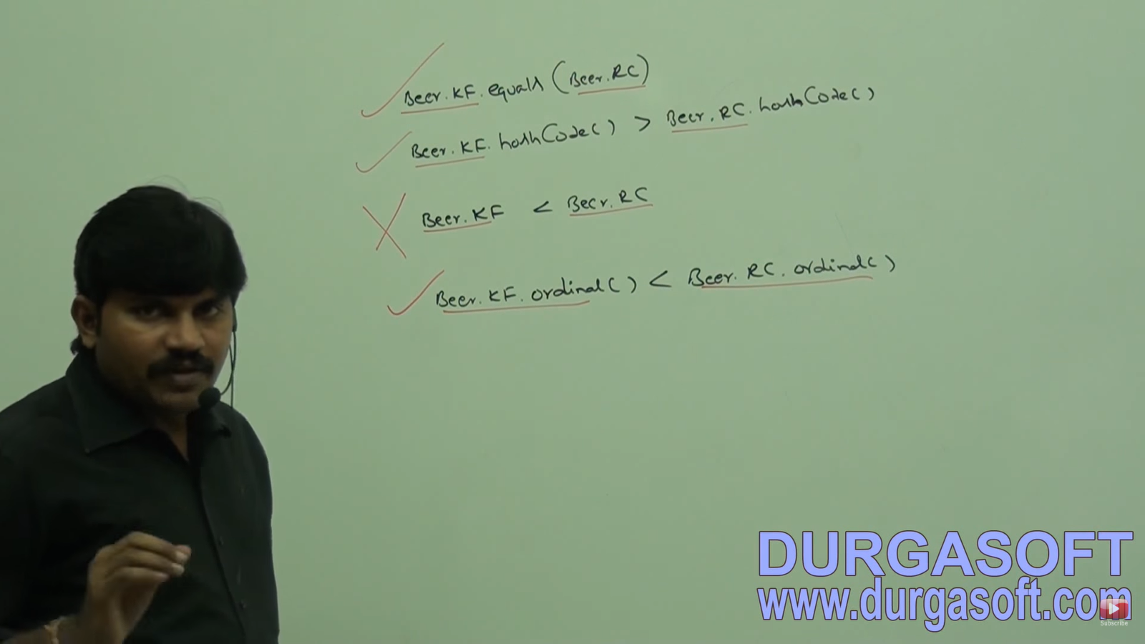

**NORMAL IMPORT vs STATIC IMPORT:**

If we want to use class or interface directly from outside package (say sqrt function of Math class)

We can use Math.sqrt() 🡨 Import need to be **normal** java.lang.Math.*;

But if we do not want to use class name and use simply sqrt(), we do **static import** i.e. **import java.lang.Math.sqrt**;

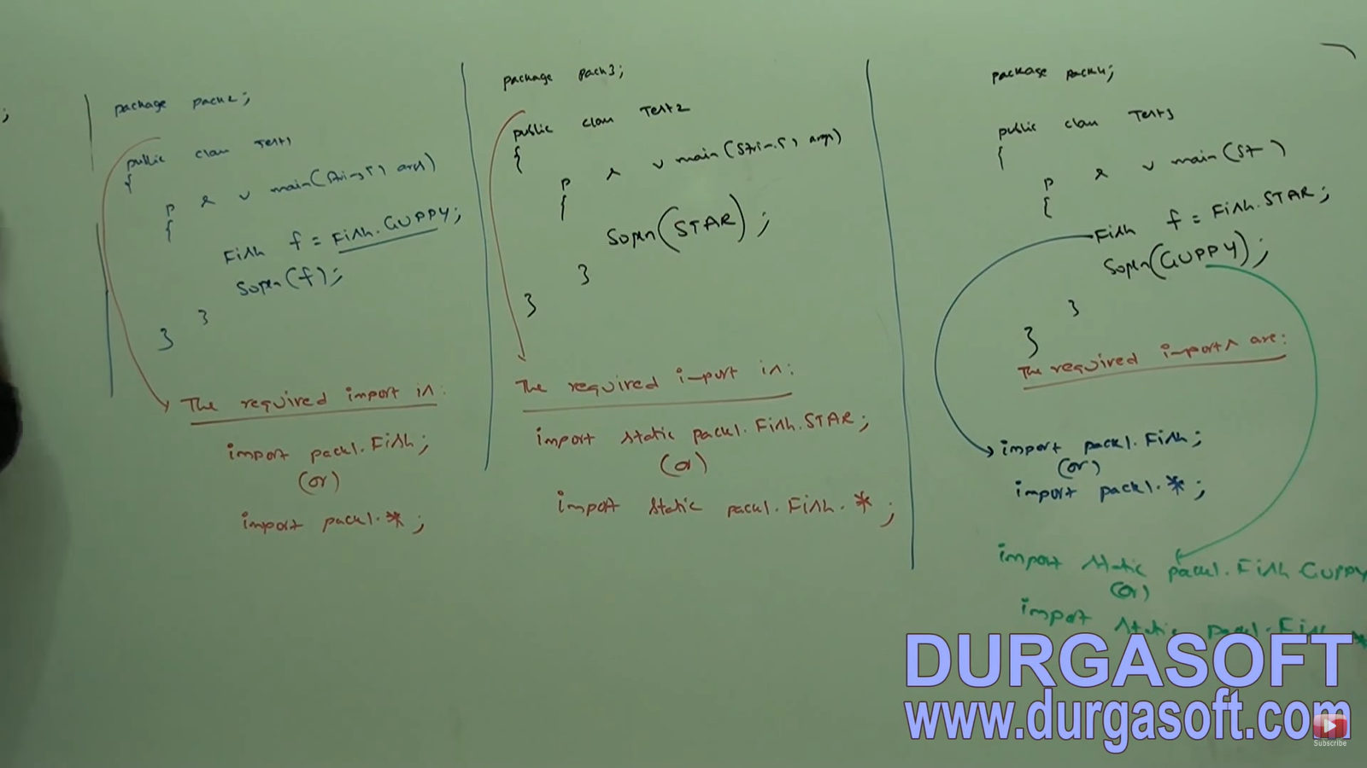

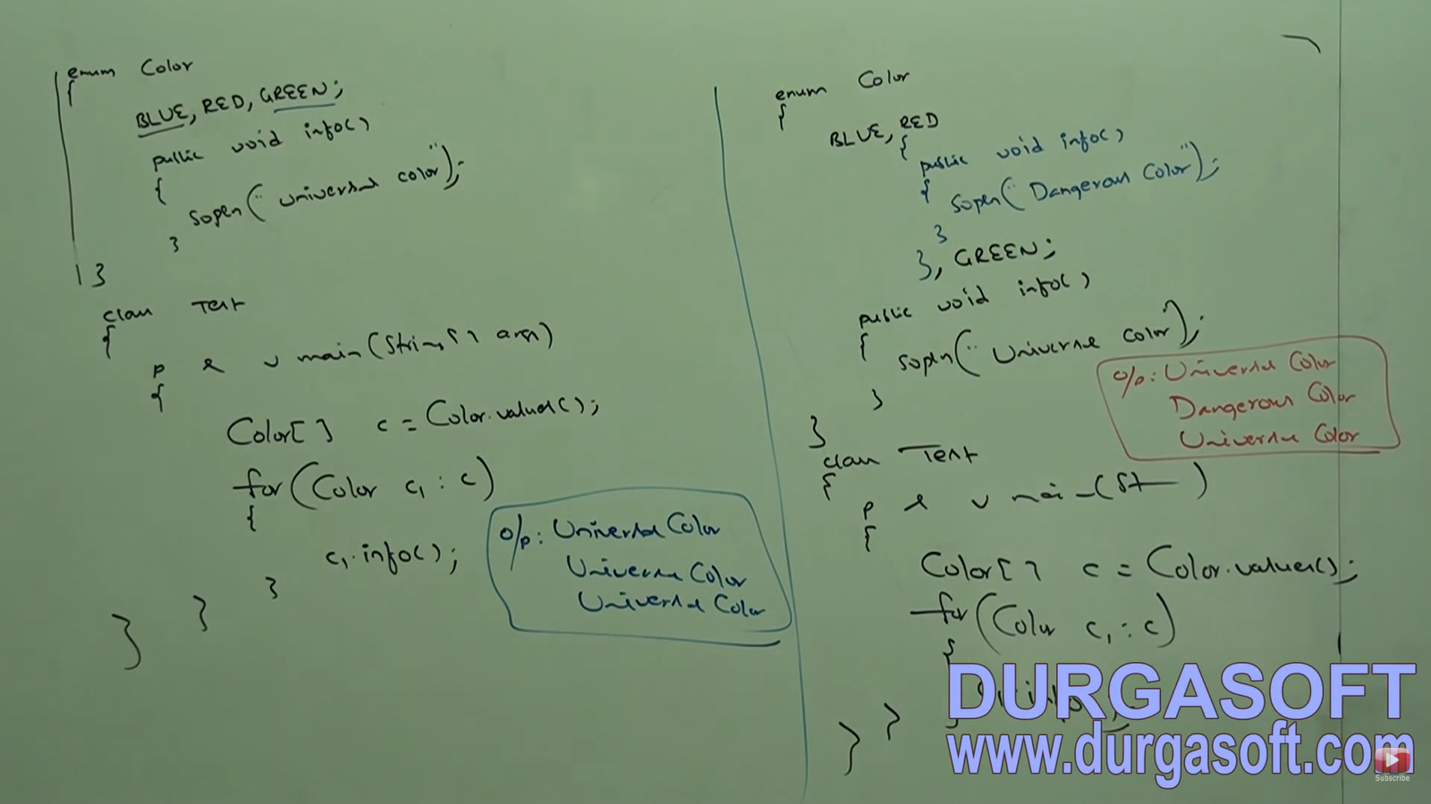

**enum vs Enum vs Enumeration**

enum is a keyword in java which can be used to define a **group of named constants**.

Enum – Is a **class in java** present in **java.lang package**. Every enum is java should be direct child class of Enum class. Hence this class acts as a base class for all java enum.

Enumeration is an **interface** present in **java.util package**. We can use enumeration object to get object one by one from the collection.

**INNER CLASSES:**

Sometimes we can declare class inside another class. Such type of classes is called inner classes.

Inner classes concept introduced in 1.1v **to fix GUI bugs as a part of Event Handling**. But because of powerful features and benefits of inner classes. Slowly programmers using it in regular coding also.

**Without existing one type of object if there is no chance of existing another type of object, then we should go for inner classes.**

Ex: A University of several departments. Without existing University, there is no chance of existing department. Hence, we have to declare department class in University class.

Ex: Map is a group of key value pairs. Each key-value pair is called an entry. Without existing map object there is no chance of existing entry object. Hence, interface entry is defined inside map interface.

Without existing outer class object, there is no chance of existing inner class object.

The relation between outer class and inner class is not IS-A relation but is **HAS-A** relationship (Composition or Aggregation).

Based on position of declaration and behaviors, all inner classes are divided into 4 types

1. Normal or Regular Inner Classes
2. Method Local Inner Classes
3. Anonymous Inner Classes
4. Static Nested Classes

**Normal or Regular Inner Class**: If we declaring any named class directly inside a class without static modifier, such type of inner class is called normal or regular inner class.

RE: No Such Method Error:Main (If main method is not there)

For every class a .class file will be created.

Inner class file named -------- > **Outer$Inner.class**

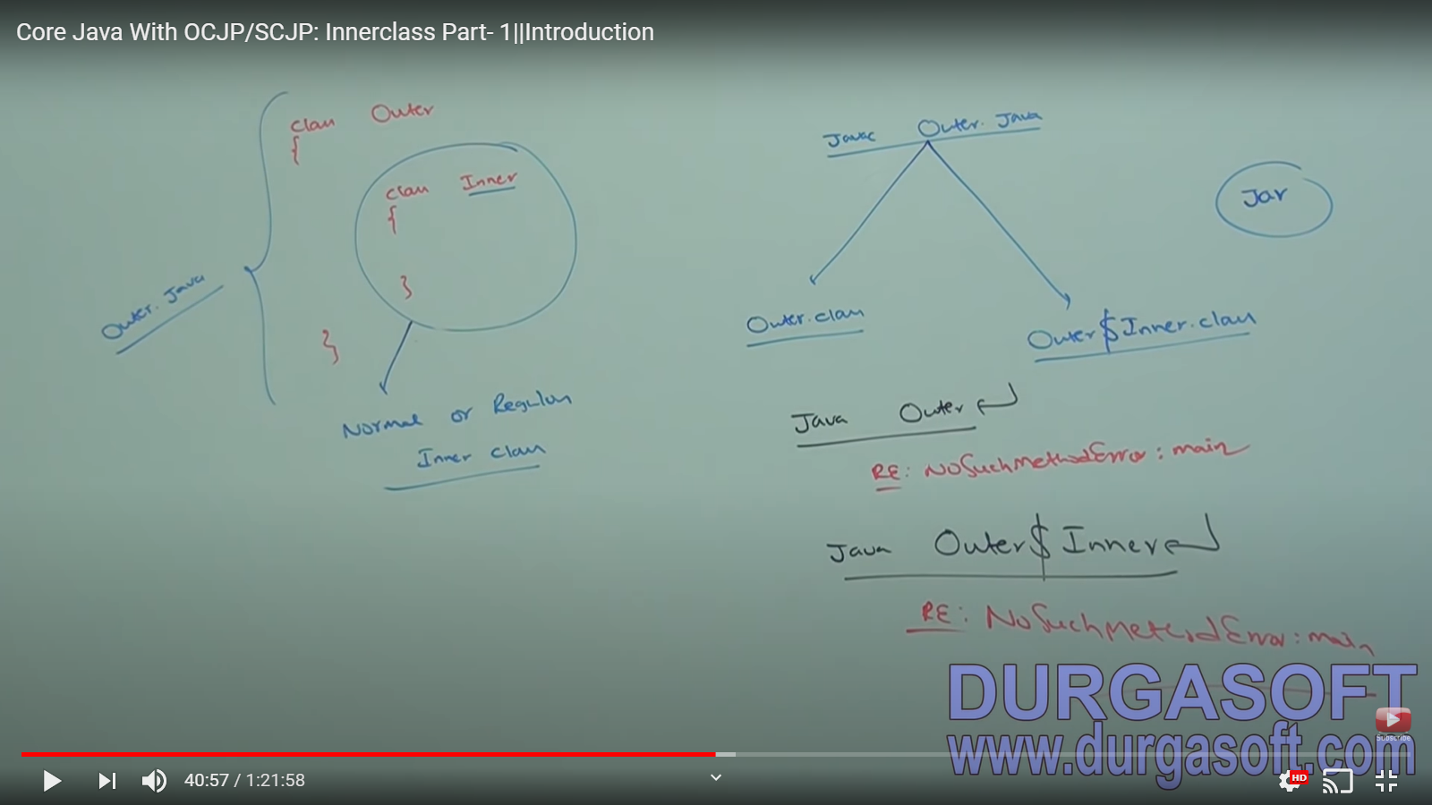

Inside inner class we **cannot declare any static members**. Hence we can’t declare main method and we can’t run inner class directly from command prompt.

.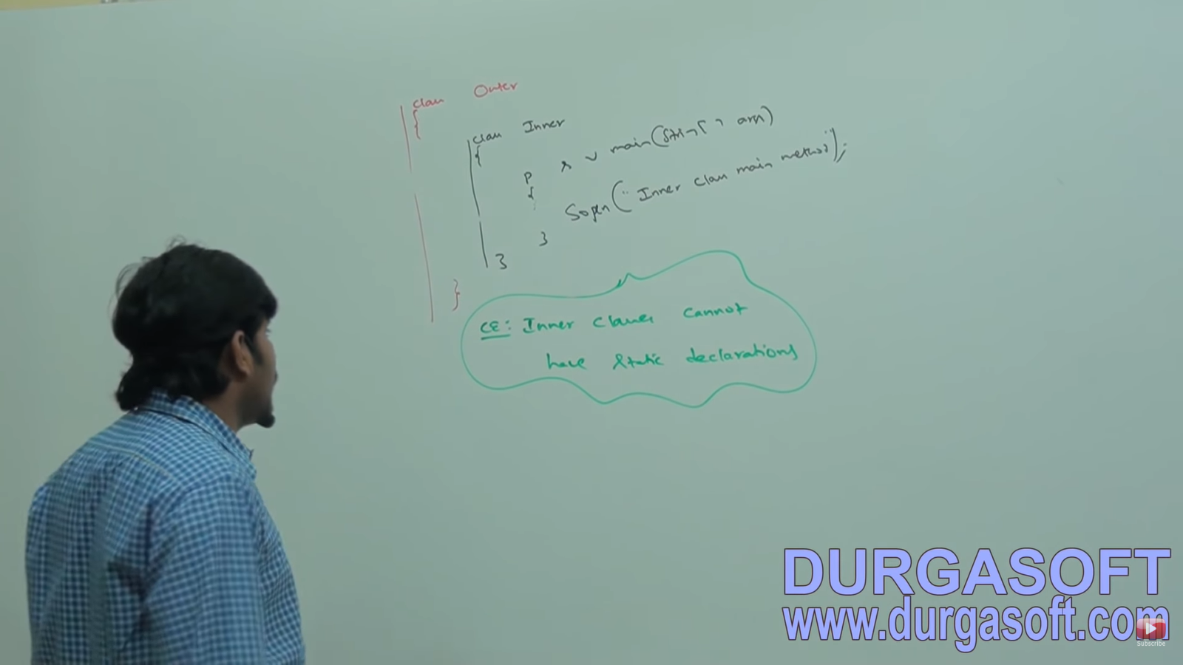

**Case -1:**

Accessing inner class code from static area of Outer Class.

Outer.Inner I = new Outer().new Inner();

new Outer().new Inner().m1();

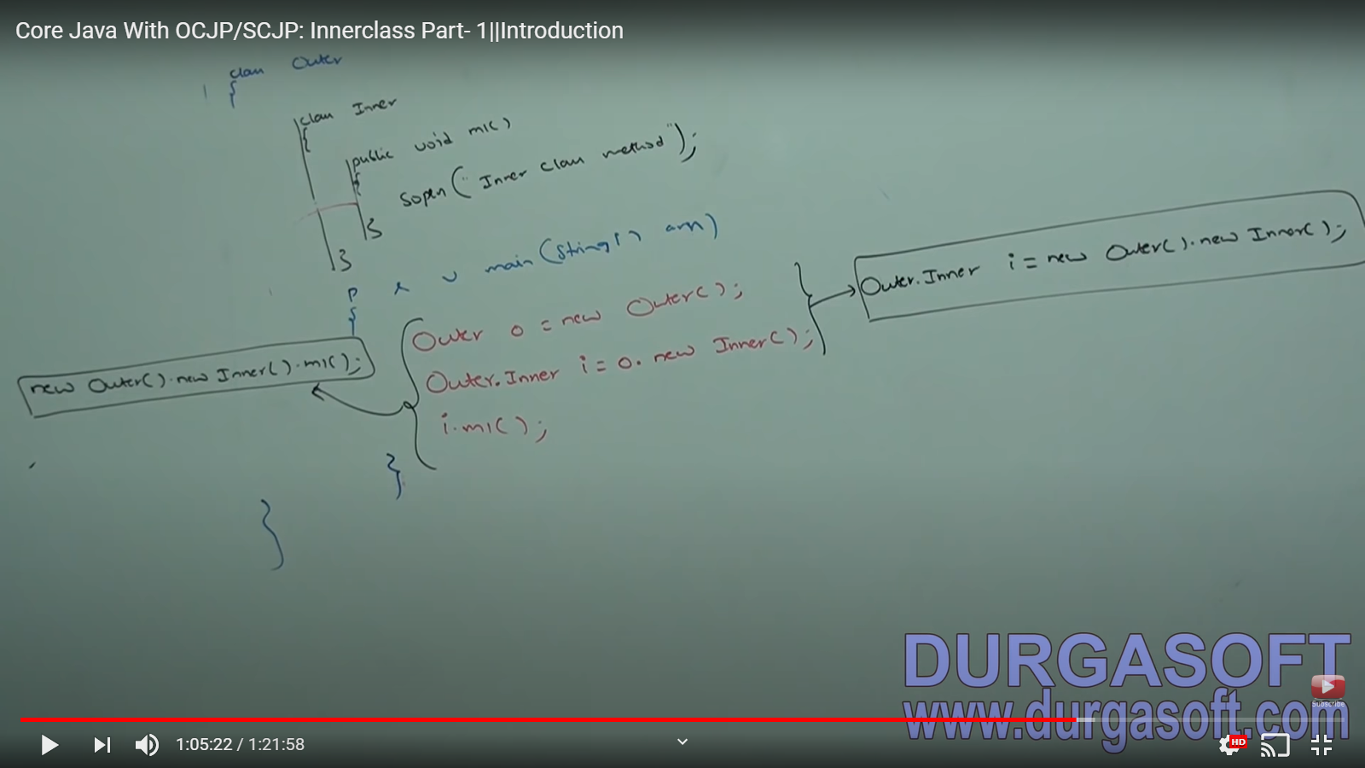

**Case -2:**

Accessing inner class code from **instance area** of Outer Class.

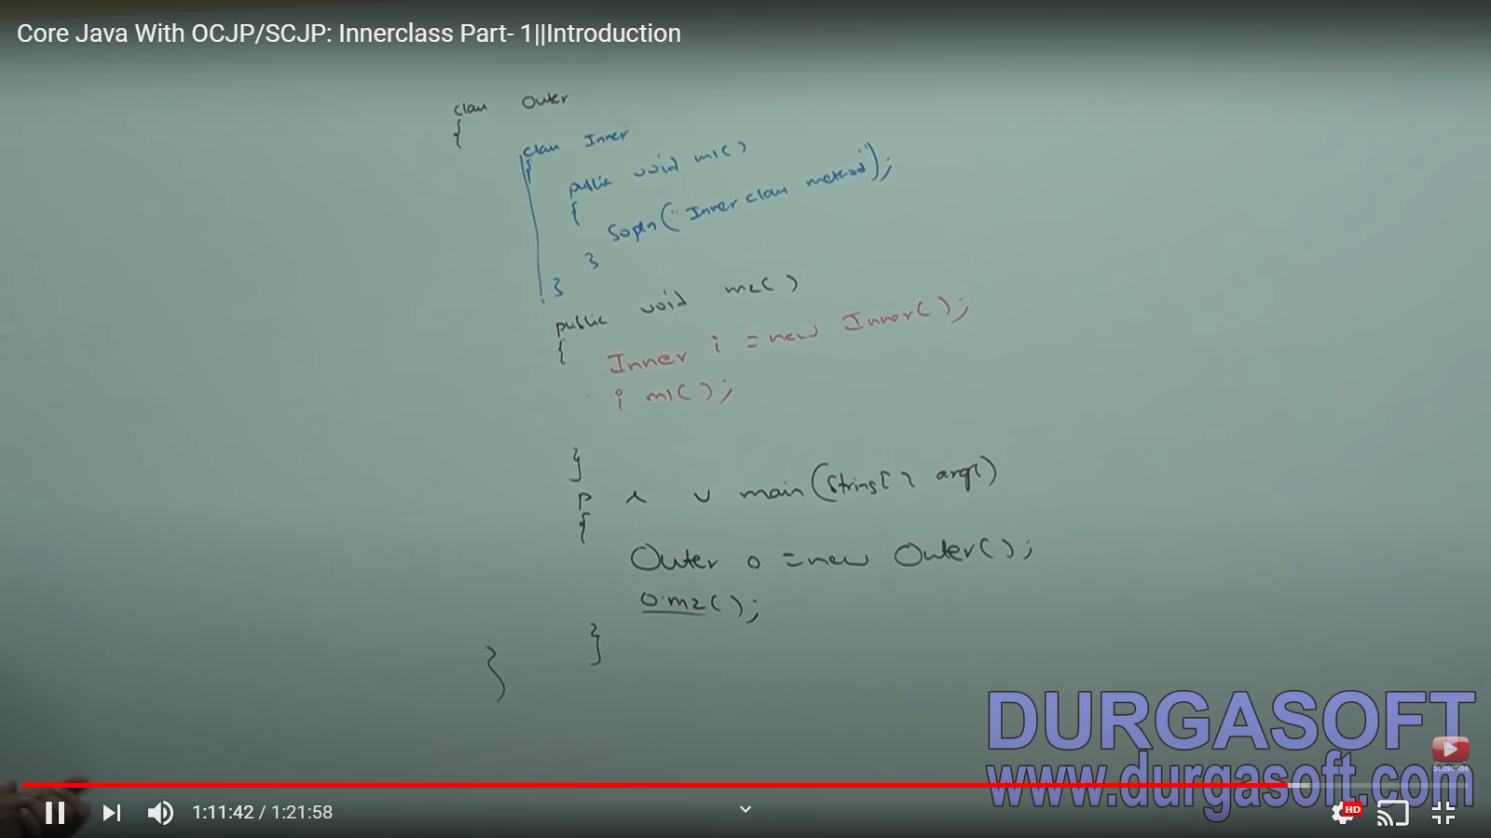

**Case 3:**

Accessing inner class code from outside of outer class:

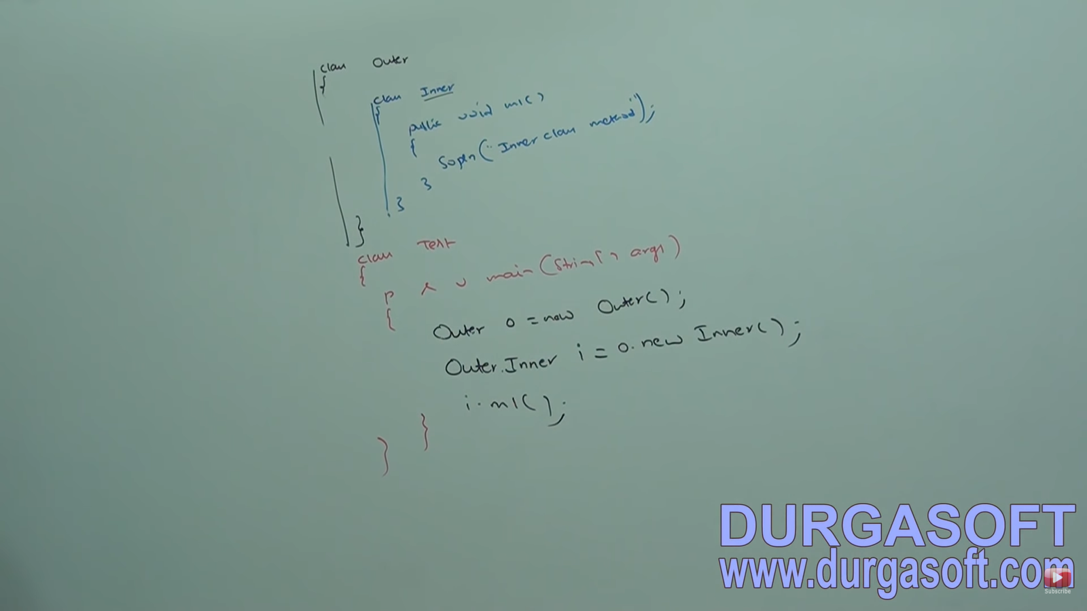

**From or regular inner class, we can access both static and non-static members of Outer Class directly.**

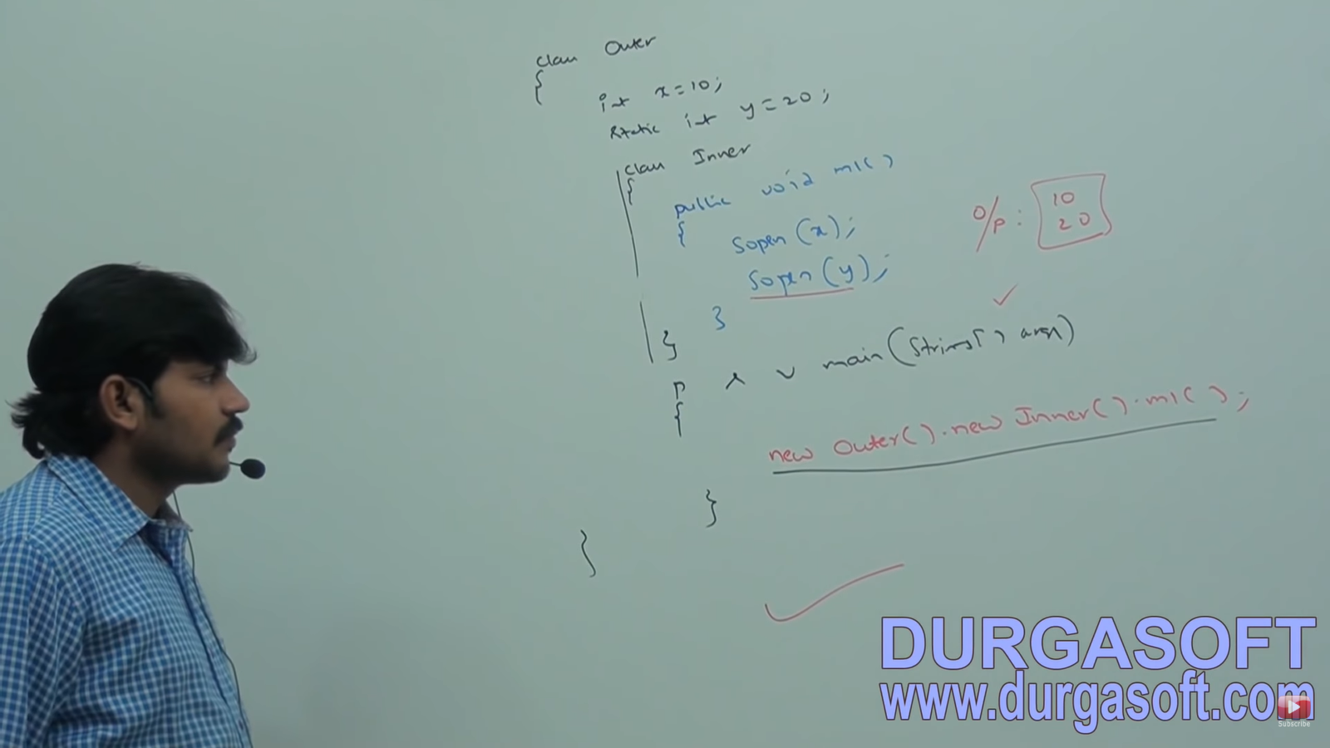

Within Inner class, this always refers to current class object. If we want to refer Current outer class object, we have to use **outerclassName.this**

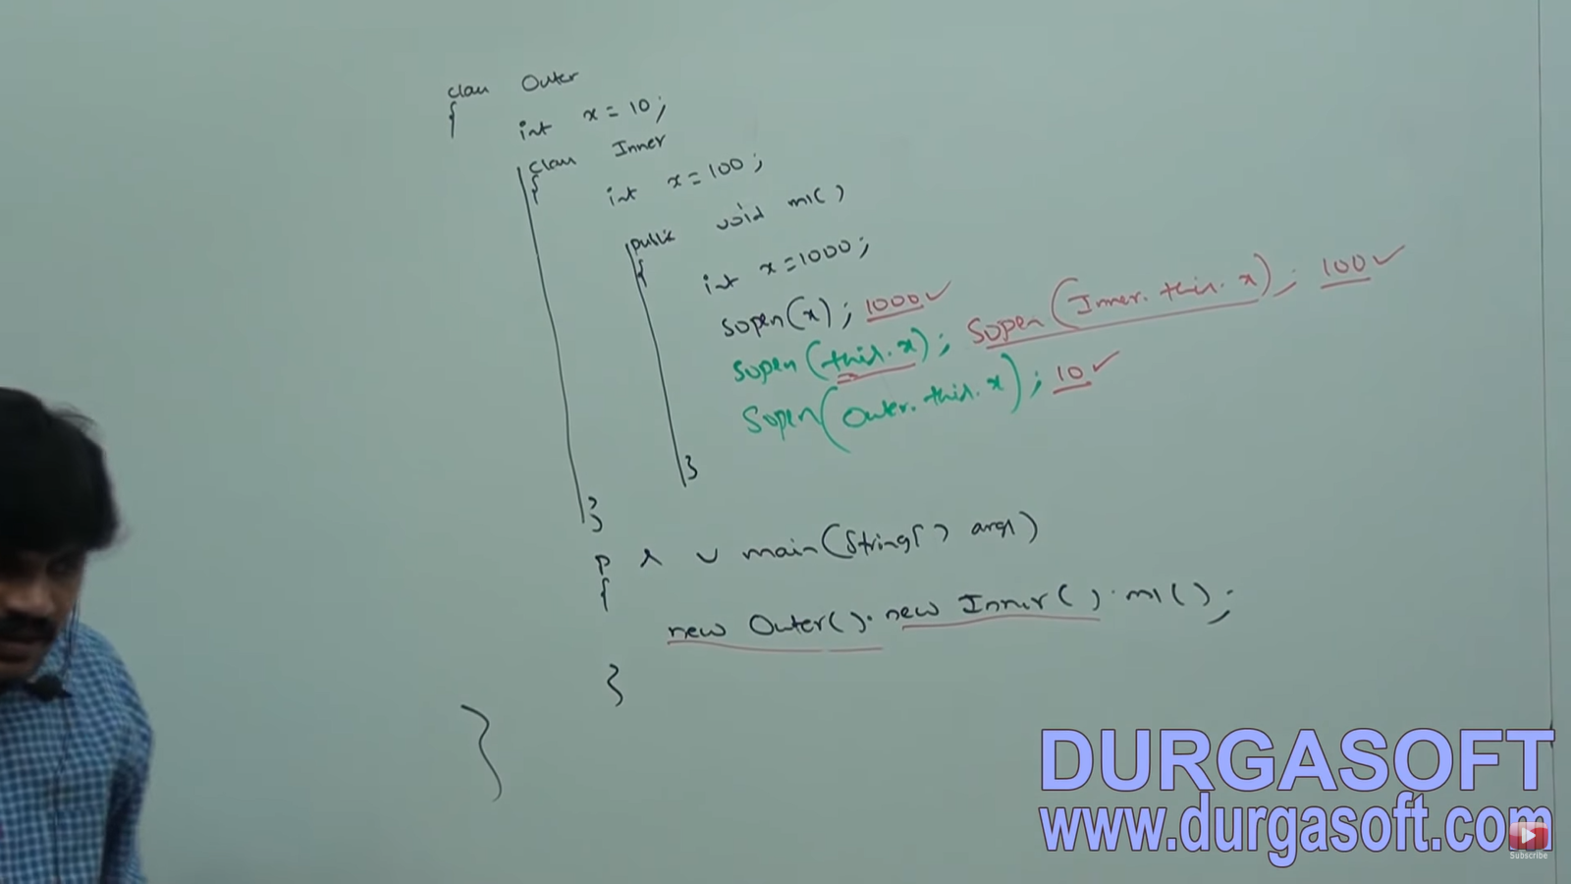

**Nesting of Inner Classes**: Inside inner class, we can declare another inner class i.e. nesting of inner class is possible.

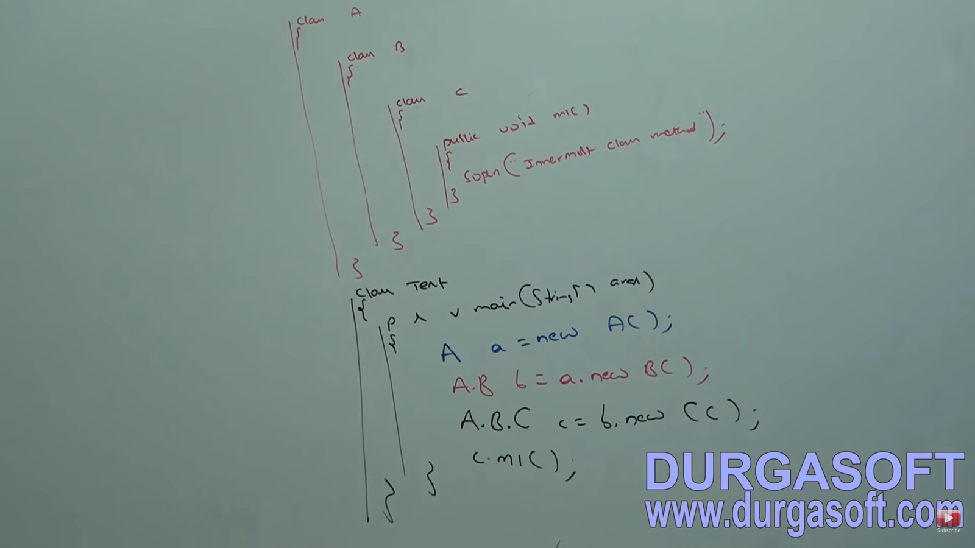

**METHOD LOCAL INNER CLASSES: MLIC**

Sometimes we can declare a class inside a method. Such type of inner class is called Method local inner classes.

Suppose we have a method with large number of line and we want to use some specific lines multiple times, then we can create a function (say ABC) and store that piece of code in that function. But we do not have nested function in Java. One option is to declare ABC at class level and call it whenever needed. But this is required only in one method and not at other places. So, we declare a Class inside the function and ABC inside the inner class.

The main purpose of method local inner class is to define method specific **repeated required Functionality**. They are best suitable to meet **nested method requirement.** They have scope only within the function. We can access MLIC only within the method where we declare it. Outside of the method we cannot access. Because of its less scope they are most rarely used.

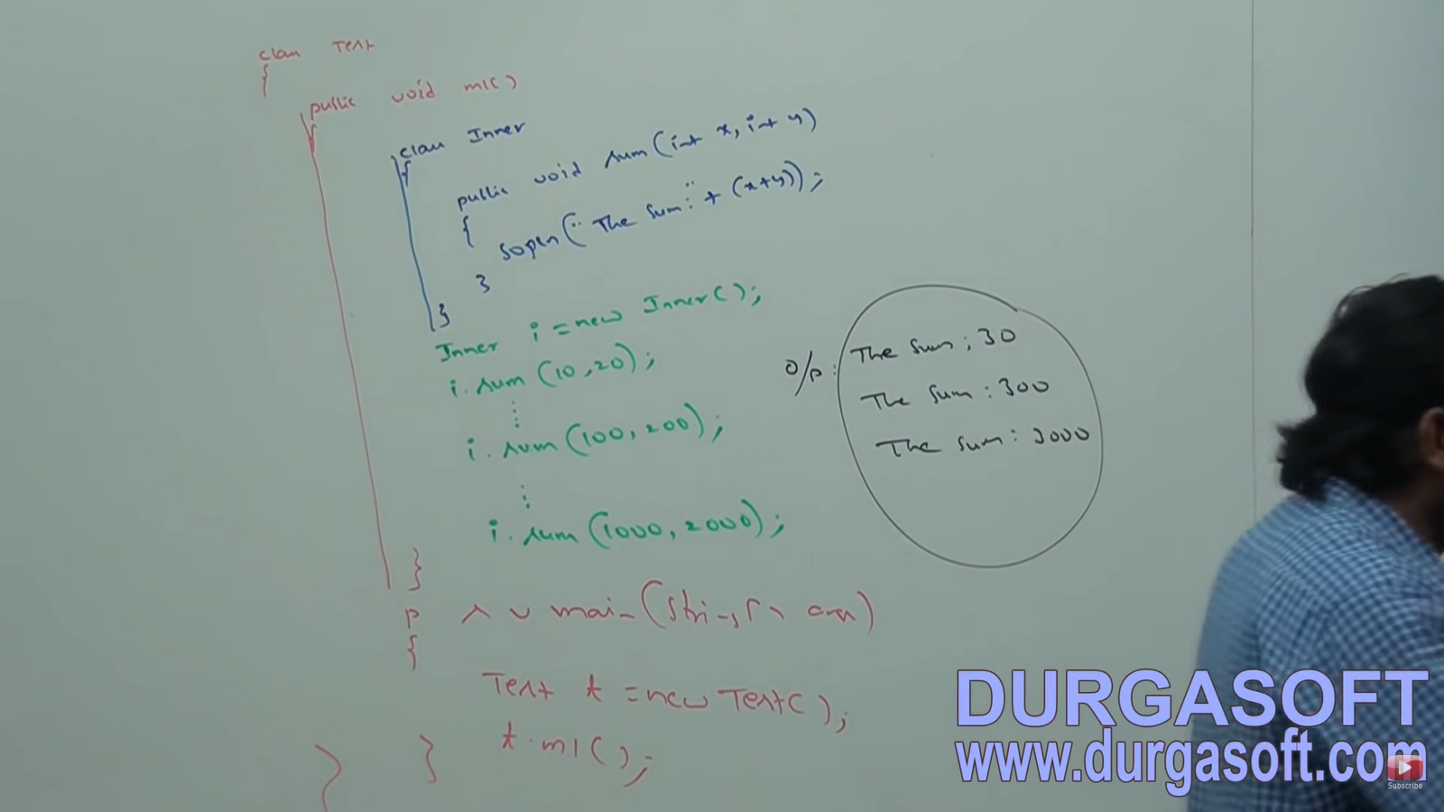

We can declare Method Local Inner class in **both Instance and static methods**.

If we declare Inner class, inside instance method, then from that method local Inner class, we can access **both static and non-static member** of outer class directly.

If we declare Inner class, inside static method, then from that method local Inner class, we can access **only static member** of outer class directly. If we declare m1 as static, then at line 1 we will get compile time error saying: Non-static variable cannot be referenced from a static context.

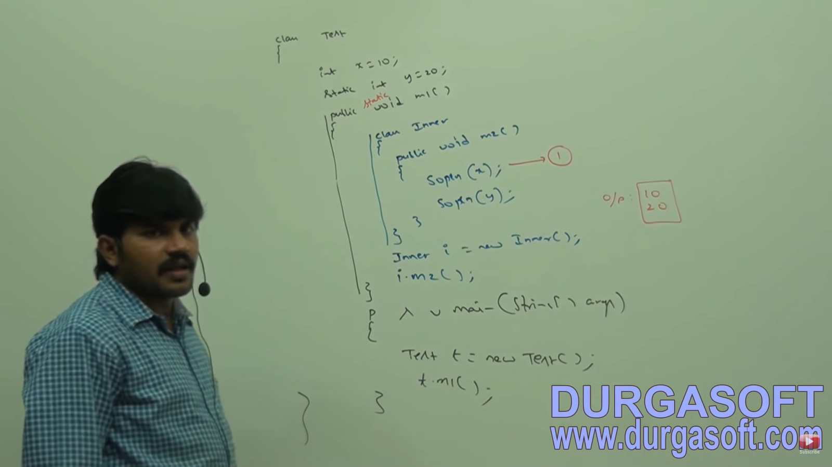

From method local inner class, we cannot access local variables of the methods in which we declare inner class. **If the local variable is declared as final, then we can access it.**

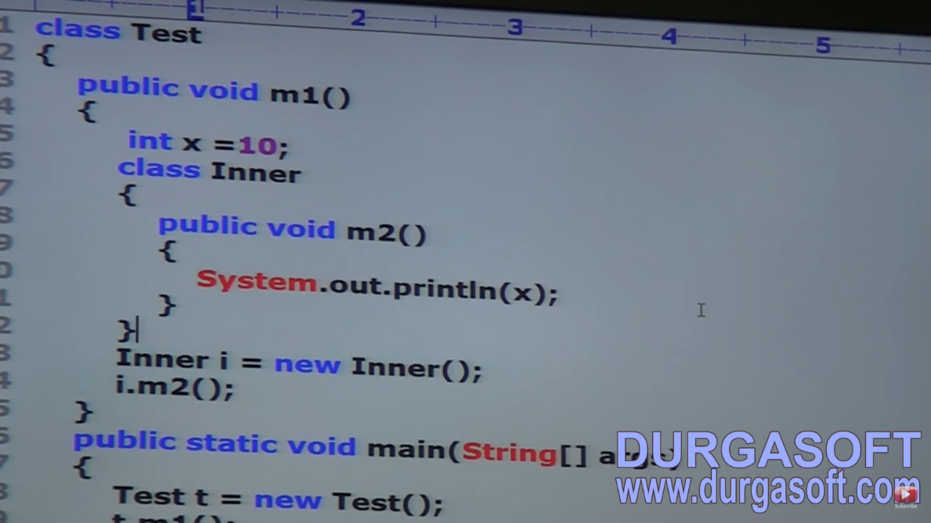

We know variable is stored inside stack. So, x will be in stack. Objects are stored in Heap. So, “I” will be stored in Heap. Every final variable will be replaced by value at compile time only. So, it will be sopln(10); if final is declared. Now, local variable will be created when m1 is called. And will be destroyed when m1 is completed. But there may be chance of object present on heap. Now if m2 is called on object, now x will be not there. So, local variables of method cannot be accessed.

Consider the following Code. At line 1, which variables can be accessed directly??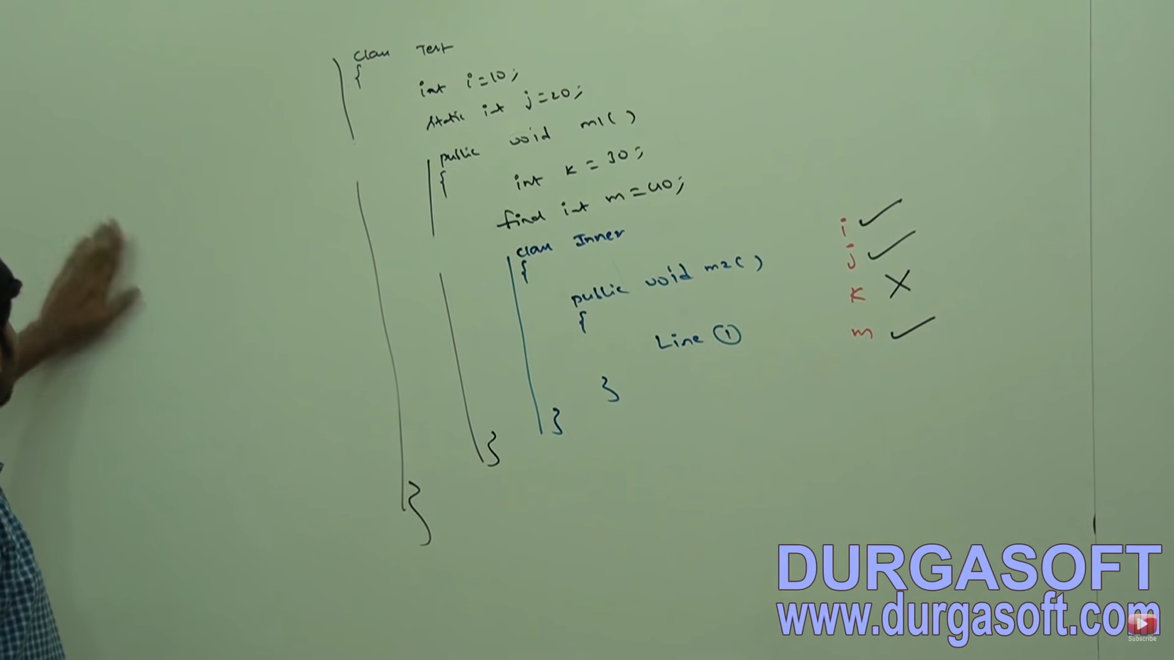 if we declared m1 method as static, we can access only j and m at line1.

If we declare m2 as static, at line1 which variables can be accessed directly?? ----🡪 We will get compile time error because **we can’t declare static member inside inner classes.**

The only applicable modifiers for MLIC are **final, abstract and strictfp**. If we apply any other modifier, we will get Compile time ERROR.

**ANONYMOUS CLASS:**

Sometimes we can declare inner class without name. Such type of inner classes are called Anonymous inner classes. The main purpose of these classes is just for **instance or one-time usage**.

Based on declaration and behavior, there are 3 types of classes

1. Anonymous class that extends a class
2. Anonymous class implement an interface
3. Anonymous class that define inside arguments

**Anonymous inner class that extends a class:**

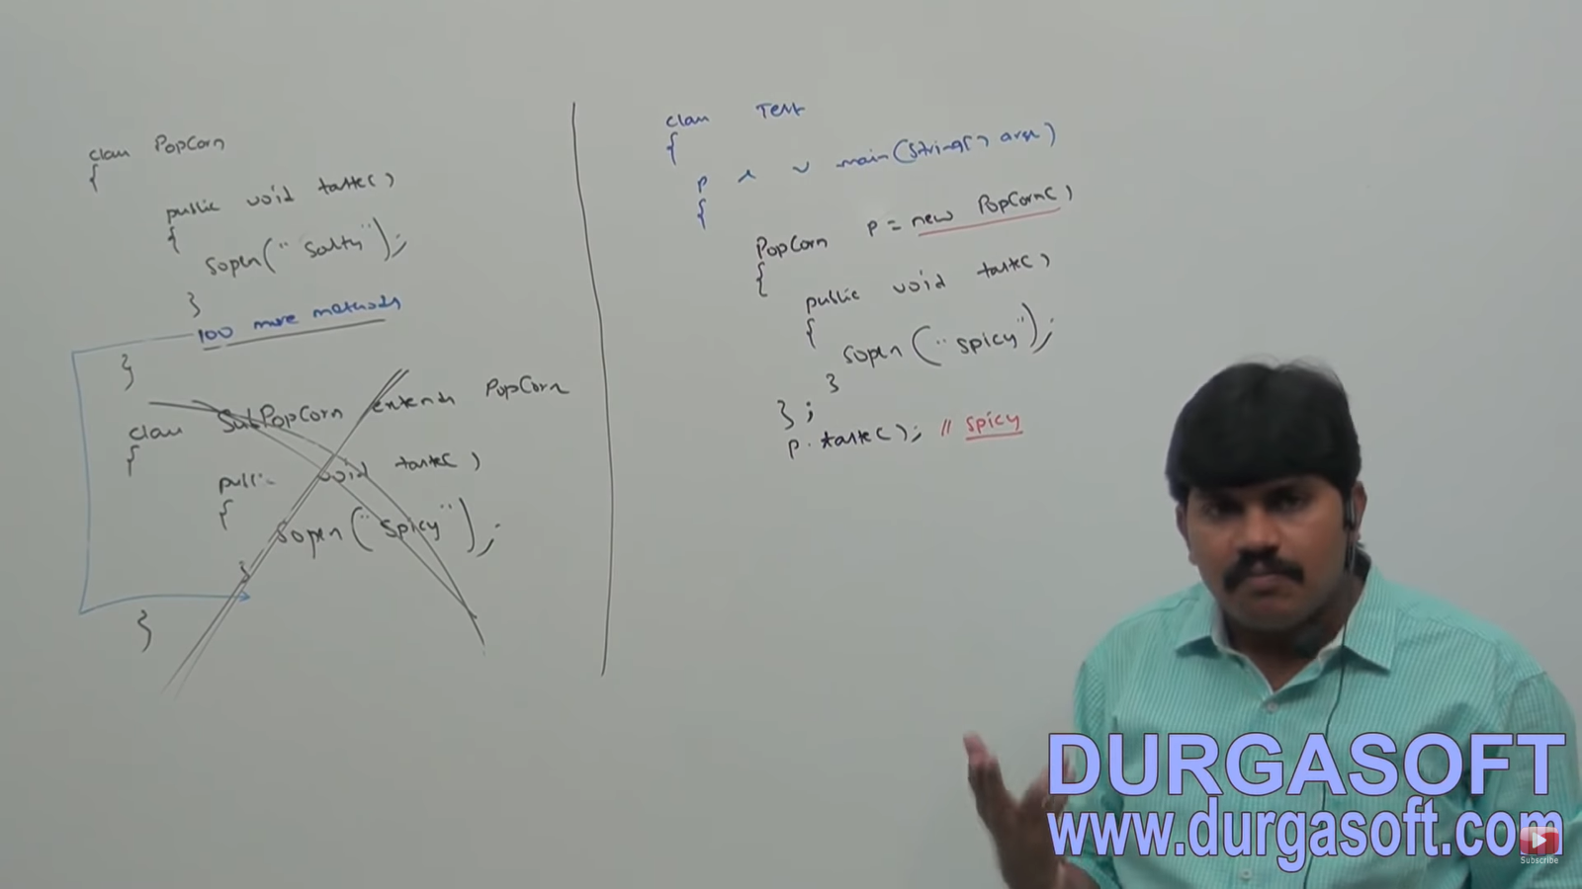

We want spicy for only one time and not always. Here we are creating a child class withoutname which is extending Popcorn. **We are creating object of child class (and not parent using new PopCorn()) with parent reference**. In the child class, we are overriding the method. No need to go for a separate child class for one-time requirement. If many time requirements there, go for a SubPopCorn.

For anonymous class also a .class file is created. Since the class is in Test class, the file name will be Test$1.class (general case **Test$i.class**). If multiple anonymous class present, for each class the value of I will be incremented in its name. We can access the class name by using ---- > **p.getClass().getName();**

Define a thread by extending thread class. Normal class approach vs anonymous Inner class approach.

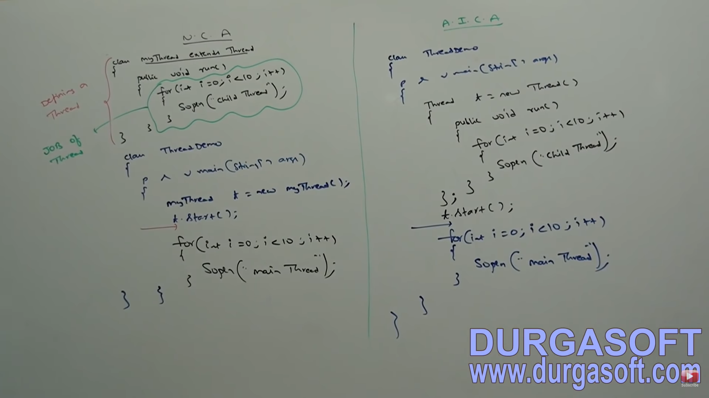

**Anonymous inner class that implements an Interface:**

Defining a thread by implementing Runnable interface. The **new Runnable is implemented class object and not Runnable Object**. We cannot create object of Runnable since it is an interface.

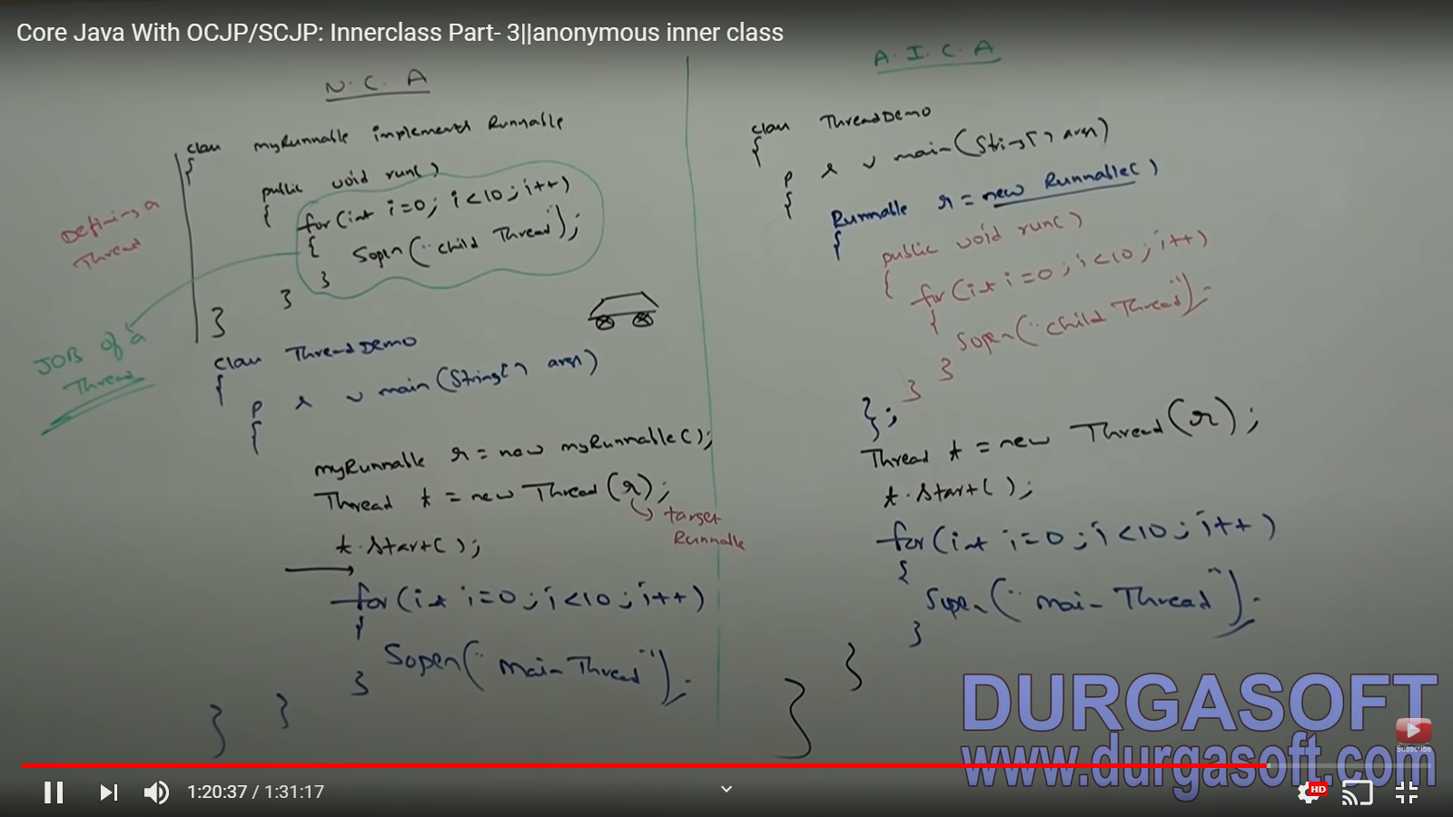

**Anonymous inner class that define inside arguments:**

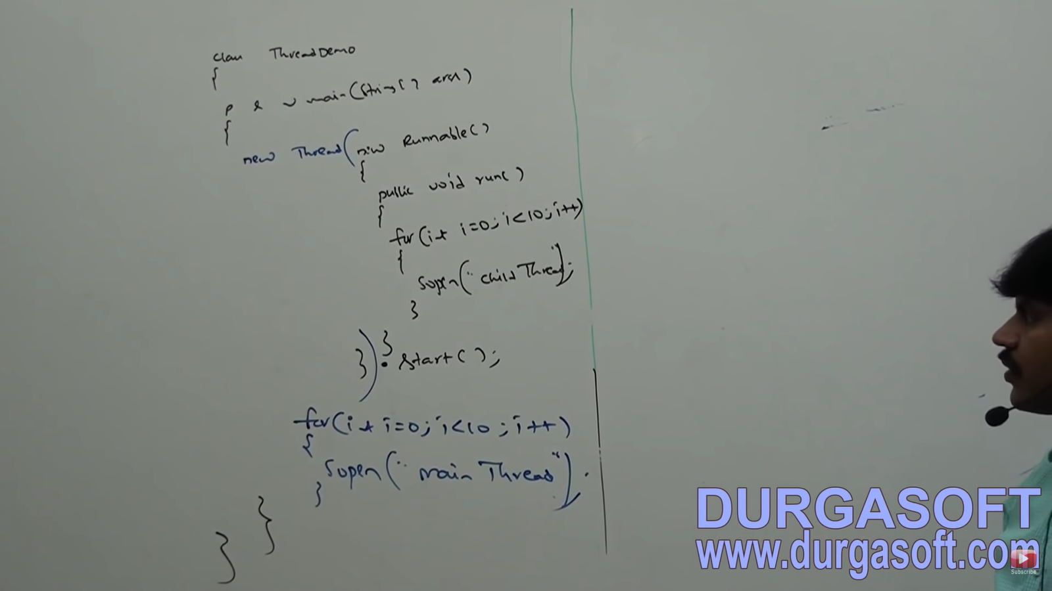

|  |  |
| --- | --- |
| **NORMAL JAVA CLASS** | **ANONYMOUS INNER CLASS** |
| Extend only one class | Extend only one class |
| Can implement any number of interfaces simultaneously | Can implement only one interface at a time |
| Can extend a class and can implement any no of interface simultaneously | Can extend a class or can implement an interface but not both simultaneously |
| Any number of constructors can be written simultaneously | **Cannot write any constructor** explicitly since the name of class and constructor must be same but it has no name. |
| If requirement is standard and required several times, go for this | If requirement is temporary and required only once (instant use), go for this |
| Best Suitable | Used frequently in GUI based applications to implement EVENT HANDLING |

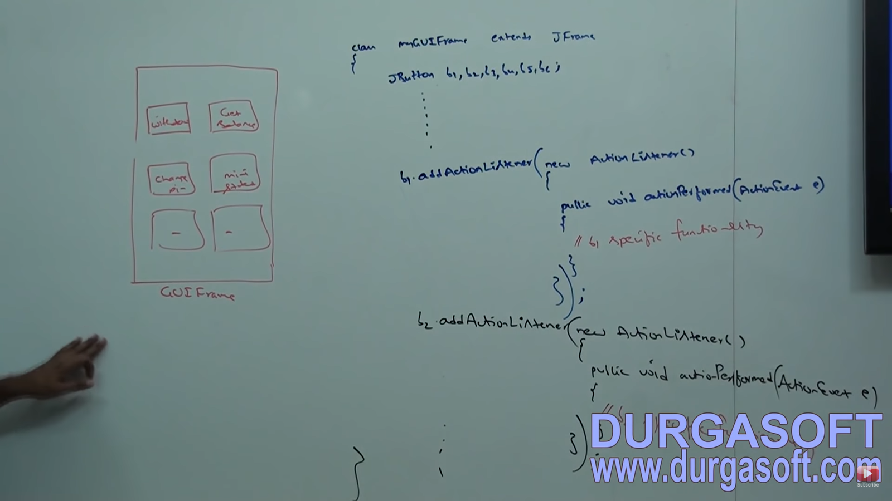

ActionListener is an interface. Here one action say b1 performs different functionalities. So, every functionality is required only once and not by others.

**STATIC NESTED CLASSES:**

Sometimes, we can declare inner class with static modifier. Such type of inner classes is called static nested classes. Instance variable is always part of object. So there does not exist an instance variable without object. But static variables can exist without objects.

So, we can say that **non-static inner class is similar as an instance variable**. Without existing outer class object there is no chance of existing inner class object. Similarly, without existing outer class object, there is a chance of existing nested class object.

So, static nested class object is not strongly associated with outer class object. So, it is nested class. Similarly, static variable is not strongly associated with class object.

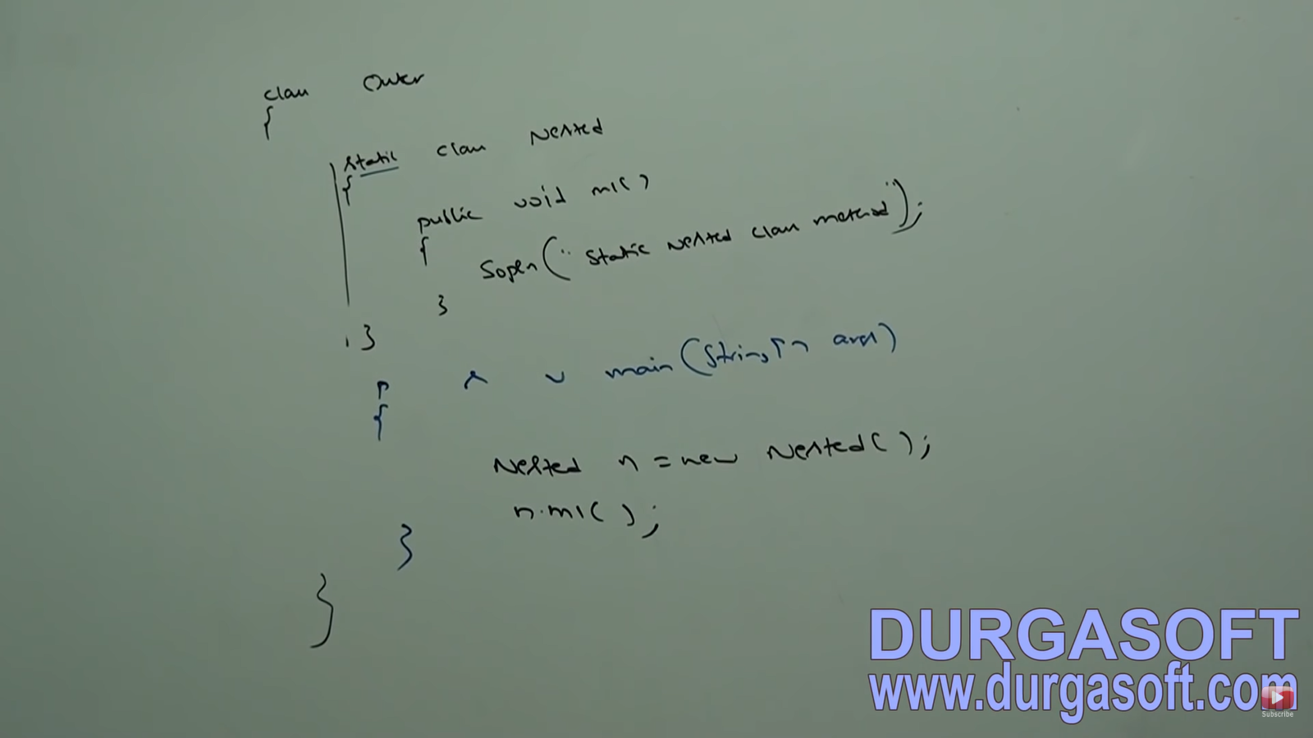

For use from outside the Outer class, we do **Outer.Nested n = new Outer.Nested();**

In normal inner class, we cannot declare any static members and hence, also main method. **But in nested static class, we can have static methods and also main method.** Hence, we can invoke static nested class directly from command prompt (using Java name.class)

From normal inner classes, we can access both static and non-static members of outer class directly. But from static nested classes, **we can access static members of outer class directly and we cannot access non-static members.**

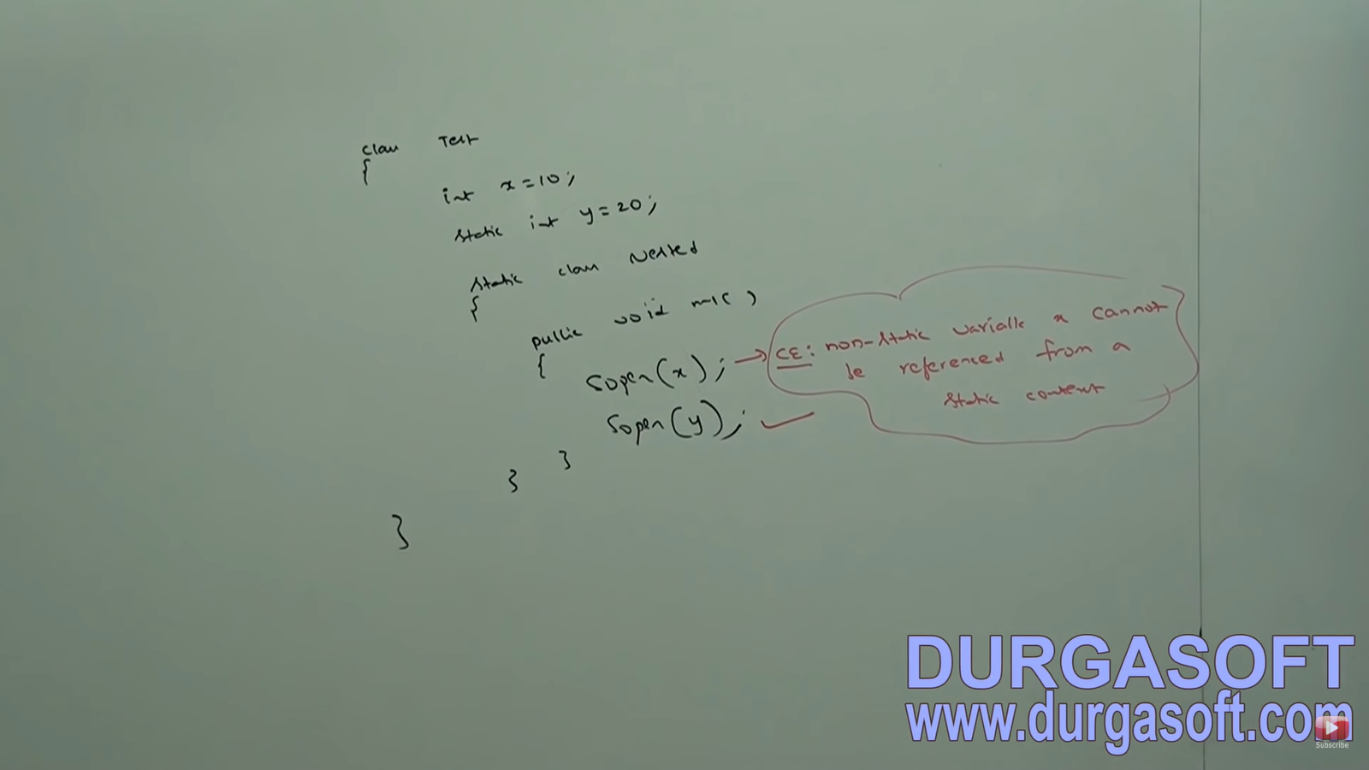

|  |  |
| --- | --- |
| **NORMAL INNER CLASS** | **STATIC NESTED CLASS** |
| Without existing outer class object there is no chance of existing inner class object | Without existing outer class object there may be a chance of existing static nested class object |
| We cannot declare static members inside | We can declare static members inside |
| We cannot declare main method inside and hence cannot invoke inner class directly from command prompt | We can declare main method inside and hence can invoke inner class directly from command prompt |
| We can access both static and non-static members of outer class directly | We can access only static members of outer class directly |

Anything inside anything is possible for interface and class.

**VARIOUS COMBINATIONS OF NESTED CLASSES AND INTERFACES:**

**CASE:1 CLASS INSIDE A CLASS**

Without existing one type of object if there is no chance of existing another type of object, then we can declare a class inside a class. Ex: University consists of several dept. Without existing university there is no chance of existing department hence we have to declare department class inside university class.

**CASE:2 INTERFACE INSIDE A CLASS**

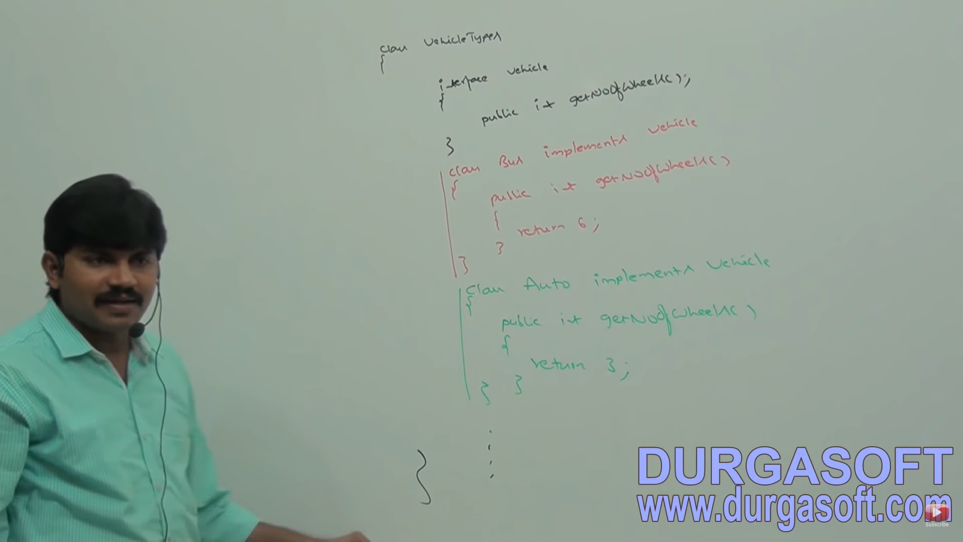

**CASE:3 INTERFACE INSIDE AN INTERFACE**

(Entry interface inside Map Interface)

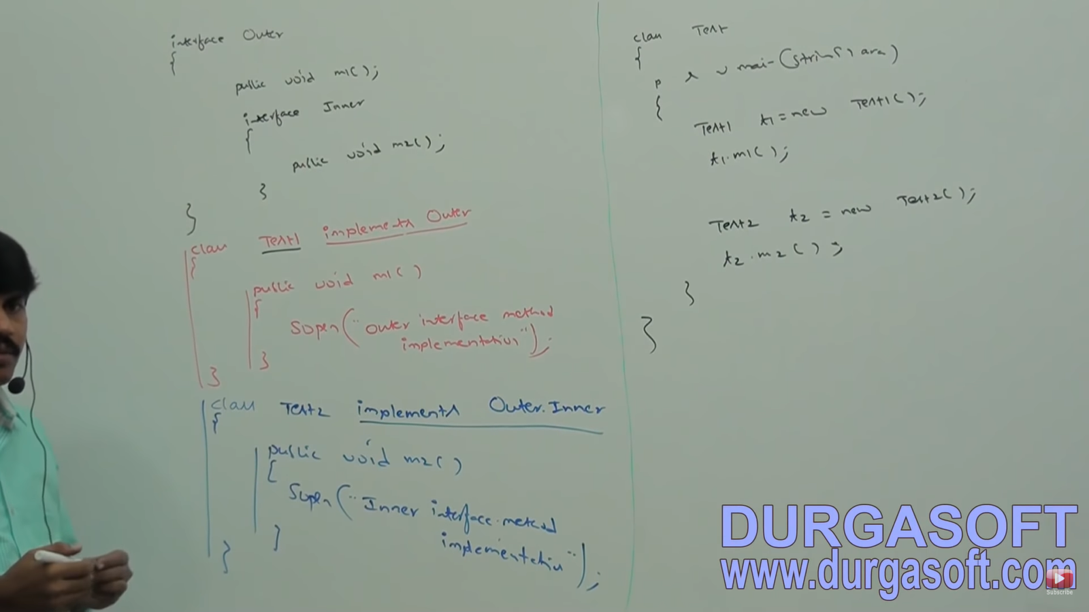

Every interface present inside interface is always **public and static** whether we are declaring or not. Hence, we can implement inner interface directly without implementing outer interface. Similarly, whenever we are implementing outer interface, we do not need to implement inner interface i.e. **we can implement outer and inner interfaces directly independently.**

**CASE:4 CLASS INSIDE AN INTERFACE**

If a **functionality of class is closely associated with interface**, then it is highly recommended to declare class inside interface.

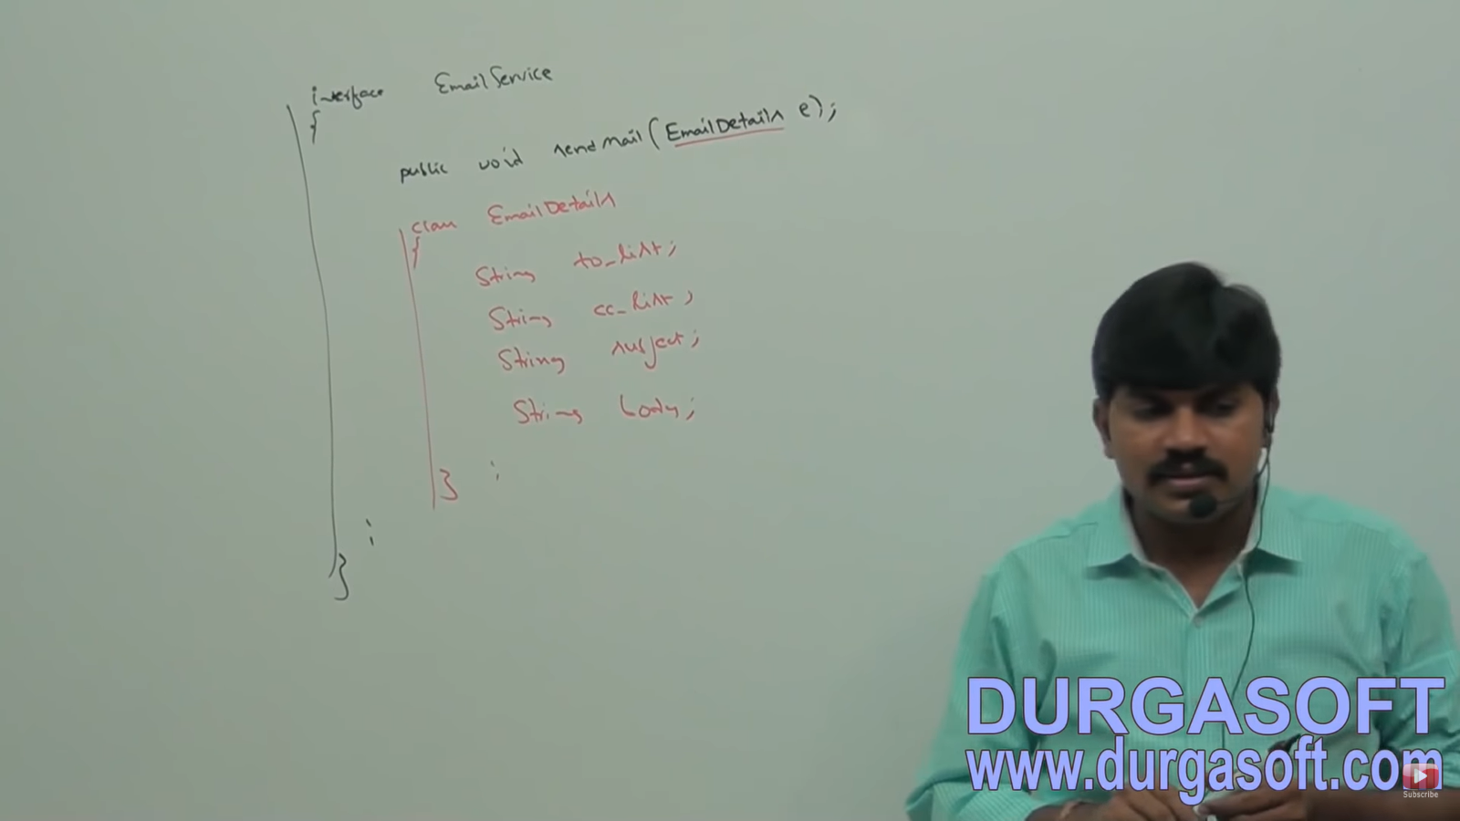

In the above example, EmailDetails is required only for email service and we are not using it anywhere else. Hence, EmailDetails class is recommended to declare inside EmailService interface.

We can also define a class inside an interface to provide default implementation for that interface.

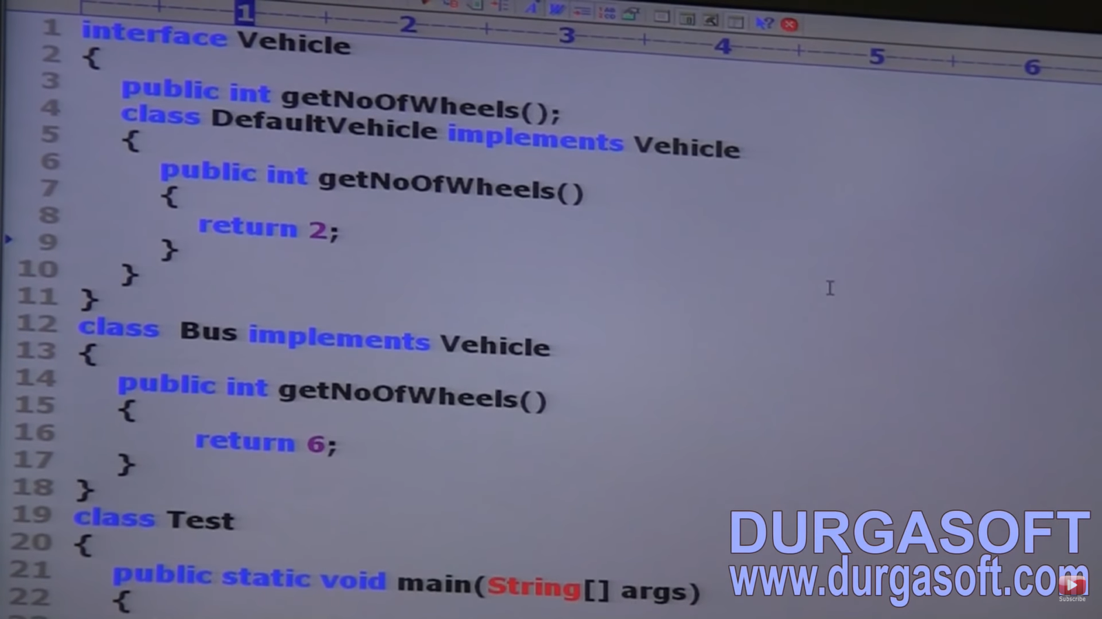

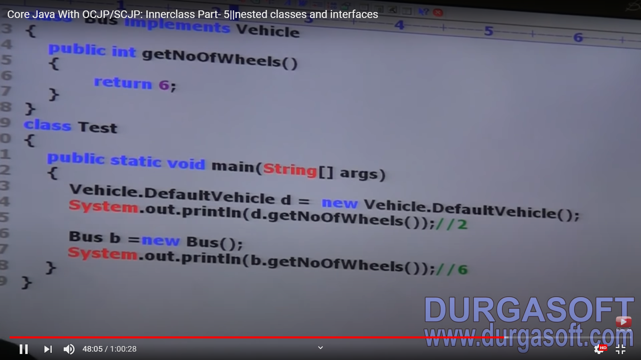

In above example, **DefaultVehicle is default implementation of Vehicle** interface whereas Bus is customized implementation of Vehicle interface.

The class declared inside interface is **by default public and static** whether we declare it or not. Hence, we can create class object directly without having outer interface type object.

All CLASS or INTERFACE declared inside interface is always **PUBLIC** and **STATIC**. Interface declared inside class is always static but need not be public (It can be default also)

